EYFS – Task 1: cutting skills. Let’s create an Easter shape chick.
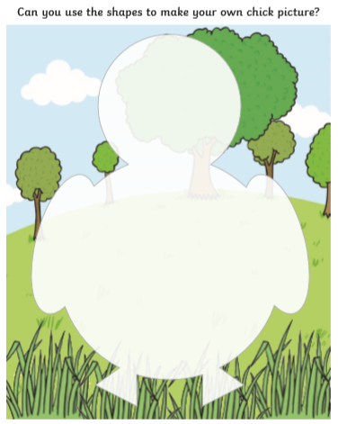

Give your chick a name and write it here:

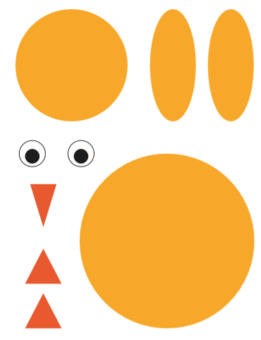

EYFS – Task 2: Let’s practise our numbers.
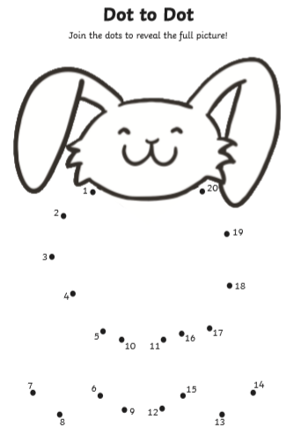

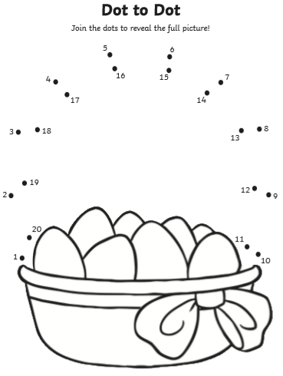

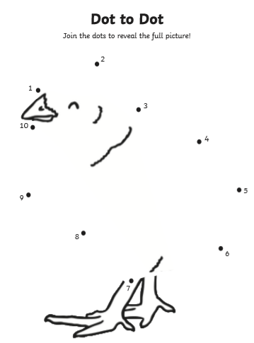

EYFS – Task 3: share the Easter story with your grown up. Then write a short sentence about what is happening in each picture.

