WALT explore the concept of forgiveness. Lesson 1: forgiveness
I can… | Self | Parent
understand what is meant by forgiveness.
use quotes and scenarios to consider the feelings that are involved when forgiving someone and when being forgiven
Task 1: What IS Forgiveness? Using the support below, introduce the term ‘forgiveness’ to your child and together decide what they think the word means and to give examples of forgiveness. Can your child explain what they think forgiveness is? Discuss the definition of forgiveness.
I think forgiveness means: ___________________________
___________________________
___________________________
___________________________

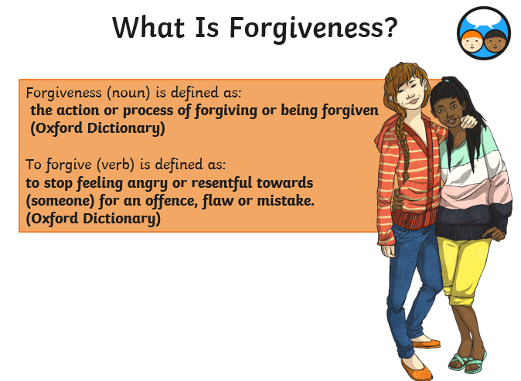
Task 2: How are the words below different from forgiveness? Use a dictionary to support. Give one example of when you have had to do/or not do each of the three words. Example: Condoning, I will not condone fighting.
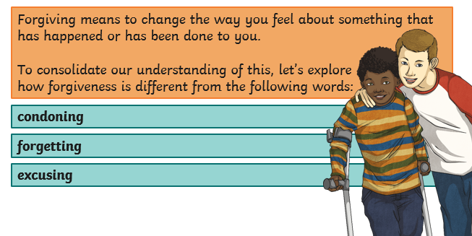
Condoning = ____________________________________________________________
_____________________________________________________________________
Forgetting = ___________________________________________________________
_____________________________________________________________________
Excusing = _____________________________________________________________
_____________________________________________________________________
Task 3: Discuss together what the following quotes mean, have your child read the scenario that goes along side it. Have your child write how this quote can help and the advice they would give to the person who would need to forgive.

Scenario 1: Two friends argue over something very small. During the argument, one friend says some very hurtful things to the other and this causes great upset and anger.
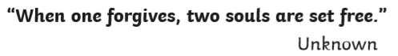
How this quote can help: __________________________________________________
_____________________________________________________________________
_____________________________________________________________________
_____________________________________________________________________
Advice I would give is: ____________________________________________________
_____________________________________________________________________
_____________________________________________________________________
_____________________________________________________________________

Scenario 2: A child received a letter claiming to be from their favourite pop star in response to the fan letter they had sent them. The child alter finds out that the friends, has in fact, written and oriented the letter for a joke. The child who received the letter had felt excited but when they find out that it was a prank they feel disappointed, hurt and foolish for believing it. They are very angry with their friend.
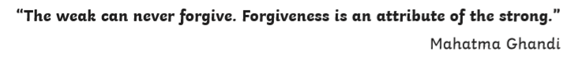
How this quote can help: __________________________________________________
_____________________________________________________________________
_____________________________________________________________________
_____________________________________________________________________
Advice I would give is: ____________________________________________________
_____________________________________________________________________
_____________________________________________________________________
_____________________________________________________________________

Task 4: Now create a scenario where this quote would help someone to remember the importance of forgiveness. 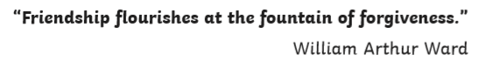
________________________________________________________________________________________________________________________________________________________________________________________________________________________________________________________________________________________________________________________________________________________________________________________________________________________________________________________________________________________________________________________________________________________________________
Task 5: Now create your own quotation on forgiveness and represent it as a poster below.

WALT explore and discuss what Jews believe about forgiveness. Lesson 2: forgiveness
I can… | Self | Parent
use specialist vocabulary to talk about how Jews understand forgiveness
reflect upon a time when I asked for forgiveness.
compare my experience of forgiveness to the experience Jews might have when seeking forgiveness.
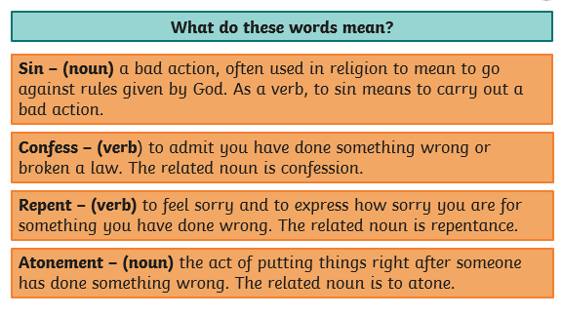
Task 1: discuss with your child the following 4 words and their meanings (support below) and discuss with them when they may have done each of the words. Sin, confess, repent and atonement.

Task 2: Discuss how Jews and Christians believe that some of the important rules God gave to human beings are the Ten Commandments. Share the picture and story below on what these religions believe happened when God shared the Ten Commandments with Moses. Explain that Jews have other commandments to follow, which are included in the Torah.
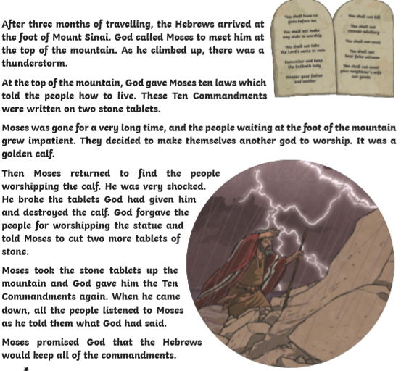

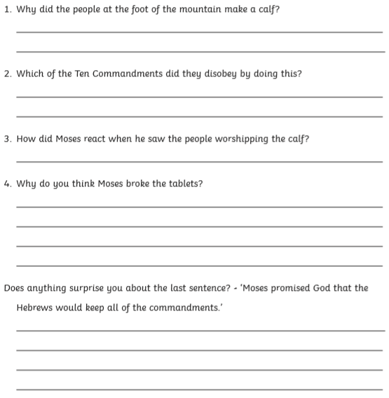

Task 4: With your child now discuss the rules that Jews live by and their beliefs about God.
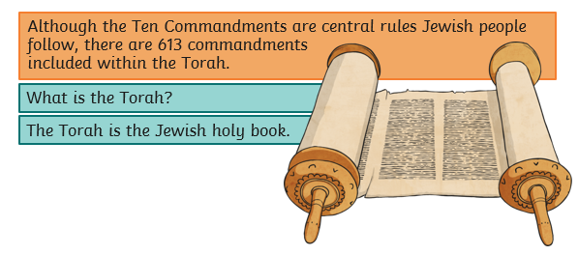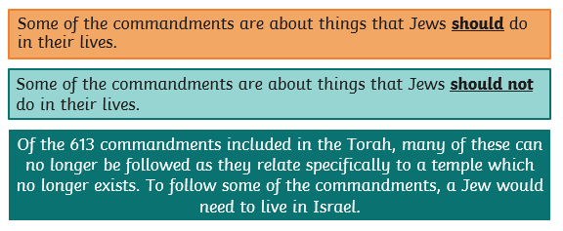
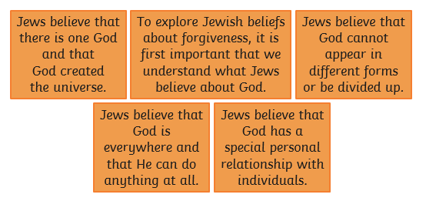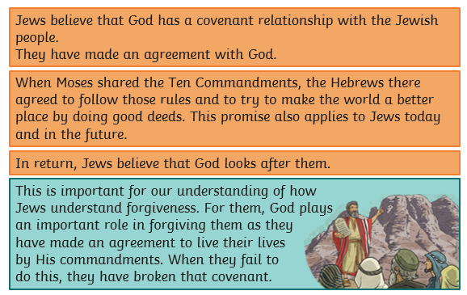
Covenant = to have a special bond, agreement with each other.
Now have your child create 10 commandments that they feel God would give today, remember all 10 are equally as important
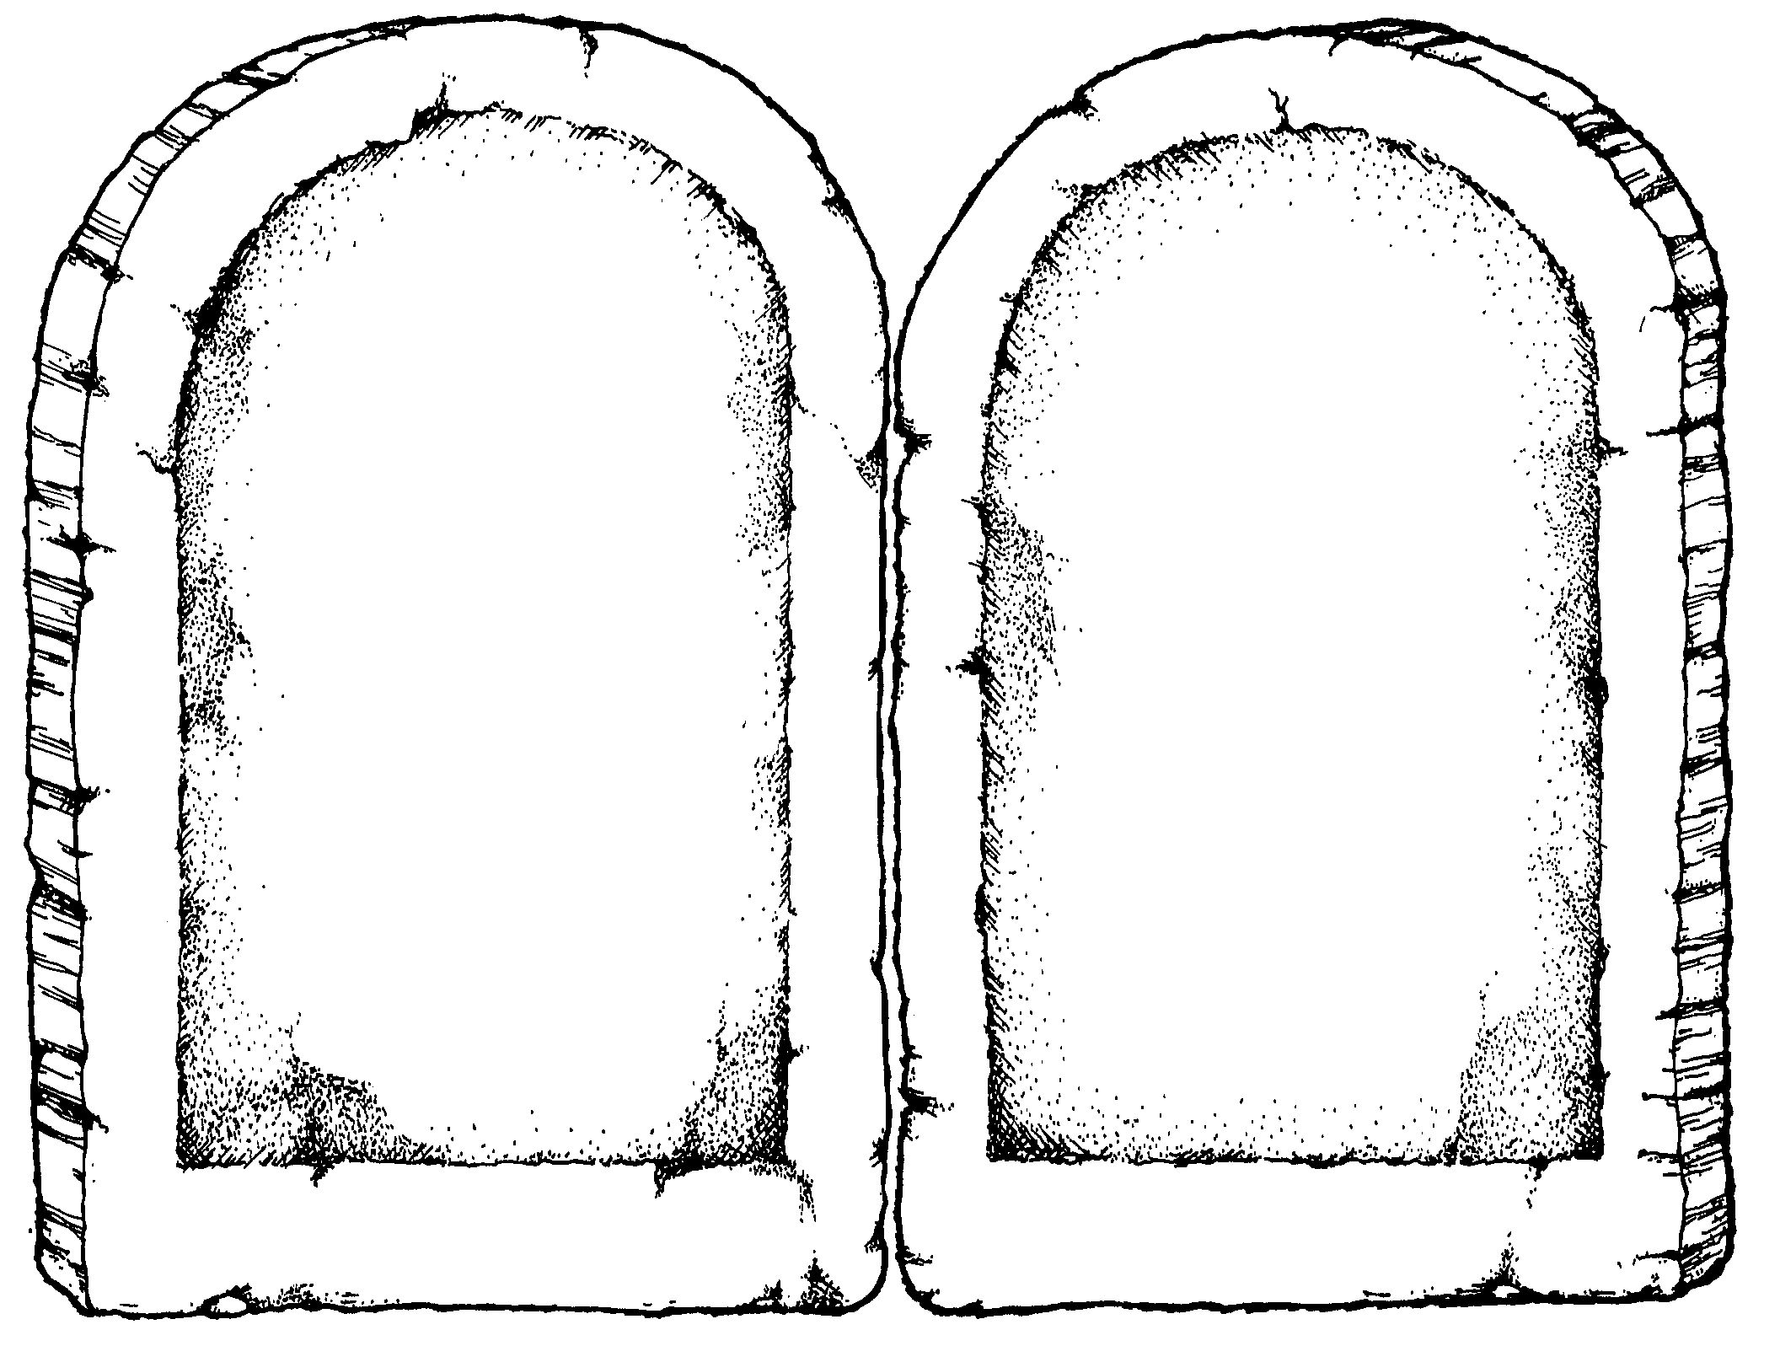
Task 5: Finally discuss with your child the importance of ‘teshuvah and explain what is meant by ‘teshuvah’ in Judaism. Discuss the steps involved.
Now discuss with your child what makes a good apology. They need to write an example of an effective and heartfelt apology that someone doing teshuvah might write to apologise.
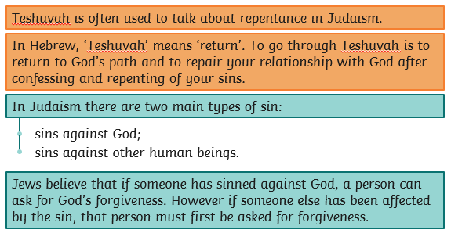

WALT explore the significance of Yom Kippur for Jews. Lesson 3: forgiveness
I can… | Self | Parent
find out about some objects used at Yom Kippur
ask and answer questions about Yom Kippur.
reflect on the feelings Jews have at Yom Kippur
Task 1: Time your child for 1 minute whilst they write down all they can remember about Judaism and forgiveness.

Task 2: Allow the children to research Yom Kippur and create a fact file, (consider when it is, where and how they celebrate, interesting facts) ensure it explains why Yom Kippur is so important for forgiveness.
Yom = __________________ Kippur = ____________________

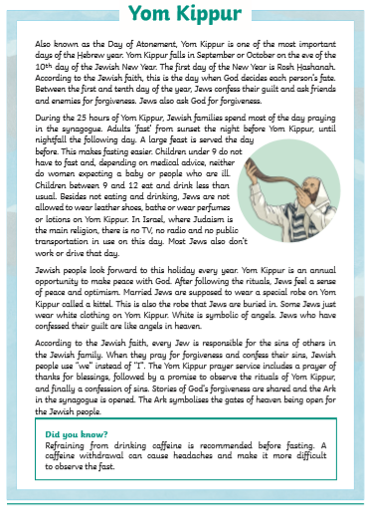

Task 3: Read through with your child about important objects during Yom Kippur. Highlight, or underline, the important parts.
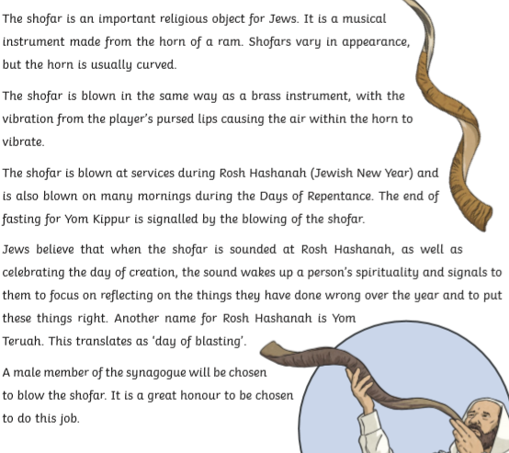
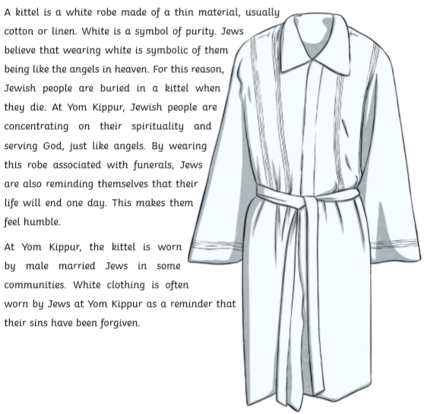

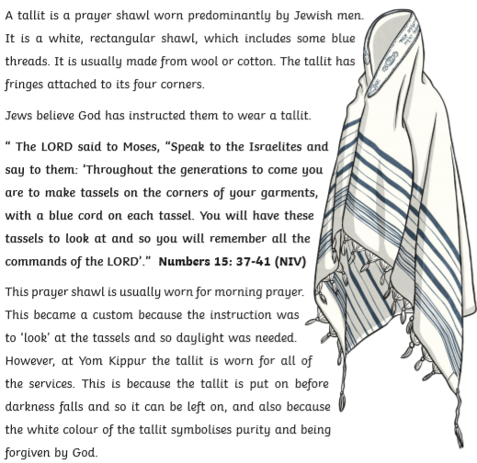
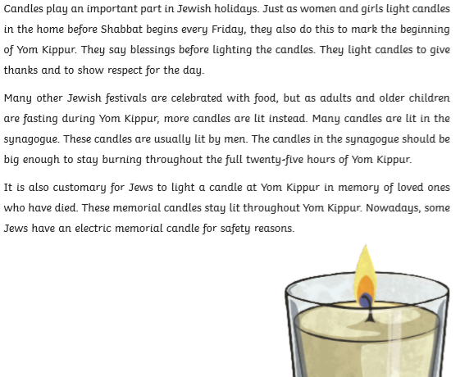Task 4: using your knowledge finish by adding your own questions and the answer, and make a Yom Kippur fortune teller.
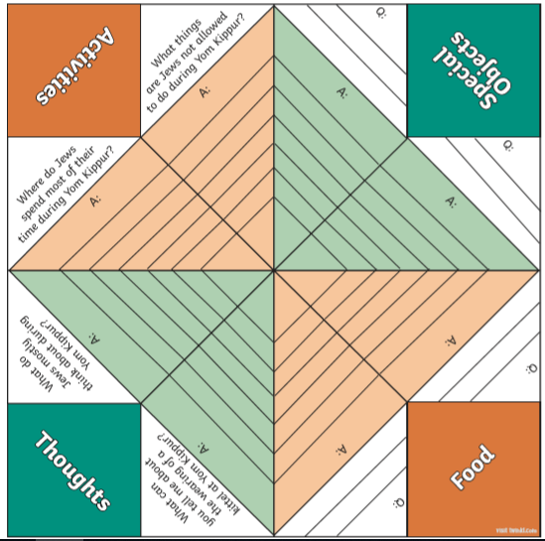
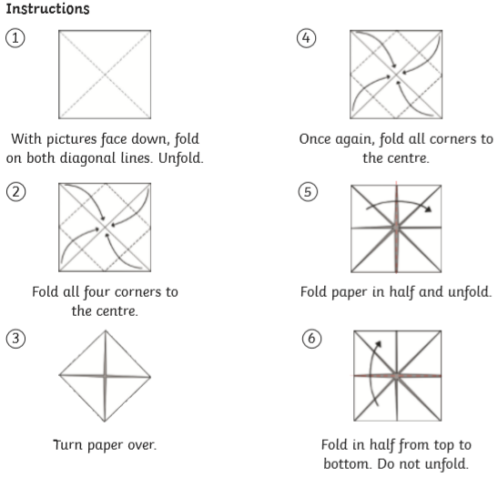

bbfnbbbvvvvvvvvvvvvvvccccxzxccc

