Outdoor learning at home
The intention of these outdoor learning activities below is to help you to connect with nature while you are at home. Outdoor learning is such a broad subject with many different approaches such as, enriching the curriculum; learning in a different context; building confidence and developing social skills; and developing a love for nature. Below are some activities to choose from. I have grouped them into EYFS, KS1, lower KS2 and upper KS1. Feel free to choose what you are comfortable with and what your child is interested in. I have chosen activities that are straight forwards and require very little resources.
And of course, if you feel confident to lead this and have an interest then this is an opportunity, albeit in worrying times, to do so.
EYFS
Session | Activity | Resources
1 | Have a look around your courtyard, garden or local wild space for some mini-beasts. Talk about what they look like, using descriptive words. Notice as much as you can about them.  When you get home or indoors, draw some of the min-beasts you saw. | Paper, pencil, colouring pencils great but not essential.
2 | Find out how many legs a ladybird has. You could look for pictures on the internet to do this, or books in your home.  Can you work out how many legs two ladybirds have? Or three?  You might need to draw them to work this out! | Access to internet or books.  Paper – scrap is fine. Or a whiteboard and pen if you have one.
3 | Find an area of soil that you can access. Use a trowel (or spoon) to dig up a small amount of soil and put it in a plastic container (old margarine but etc from your recycling). Look very carefully at the soil in your container. Can you see any mini-beasts? Are they the same type or different to the ones you spotted in activity 1? | Plastic container
4 | Save this one for a dry day!  Lie on your belly on some grass. Fix your eyes on one area – that means staring at one spot. You will notice any movement, however slight, doing this. What is travelling around in your garden? Where do you think it is going? Why? | Dry weather!
5 | Get your adult to cut a piece of string – the longer the better. They then place the string outside, over as many interesting mini areas as possible. Now, you imagine that you are a tiny creature. Imagine you are travelling alongside the string, what is it like? | String
6 | Find a nice space outside. Now imagine you are a butterfly. How would you move?  Now try the same for:  Caterpillar, woodlouse, worm, beetle, fly or spider. | Imagination
7 | 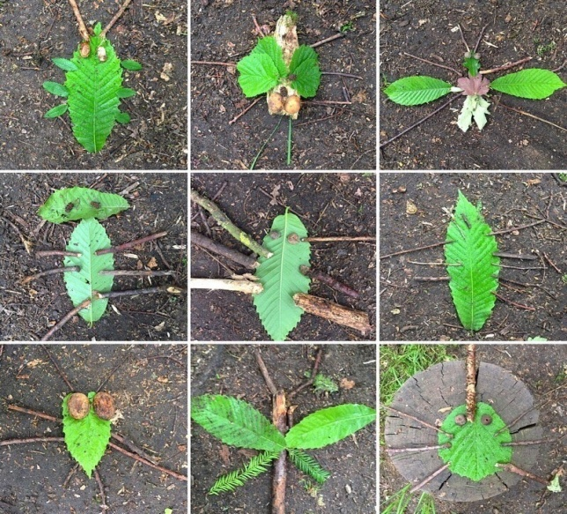  Collect some leaves, twigs and pebbles. How many different mini-beasts can you make? | Things you can find outside.  Or if you are housebound....the recycling stash.
8 | This will hopefully have inspired you to think of some other ideas...try them out.

KS1
Session | Activity | Resources
1 | Find a stick, in your garden or in a local wild area. You might even have some stashed somewhere!  Make a ‘stick person’. This could be really simple, just one stick, or have arms by attaching another stick with string. You could make some clothes using strips of scrap material (old clothes?). If you don’t have any material, you could use leaves. An adult could use a knife to scape off some of the bark and you could draw on a face.  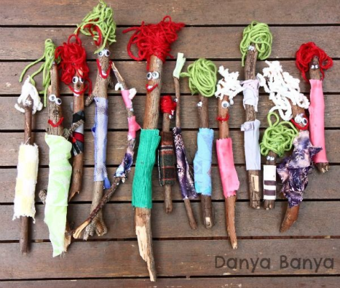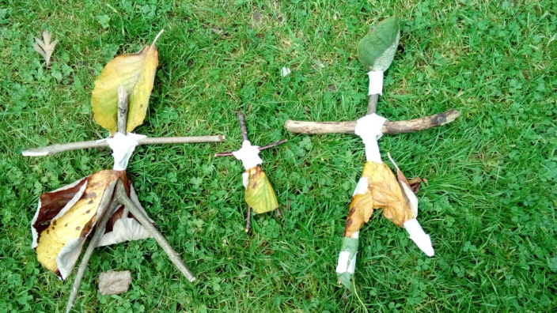 | Stick  Leaves.  If possible:  Pens, scrap material, knife, string.
2 | Make up a personality and back story for your ‘stick person’. What is their name, where do they live, what kinds of things to they like doing? What are they good at? You could share this with another person, or draw a picture and write down your ideas. | Possibly paper.
3 | Make a den for your stick person. Ideally outdoors, but indoors is fine if you have to.  You could use sticks, or fabric to make a tent. Think carefully about where you put our den so your ‘twig people’ are dry and warm.  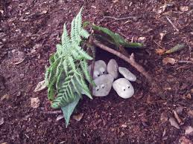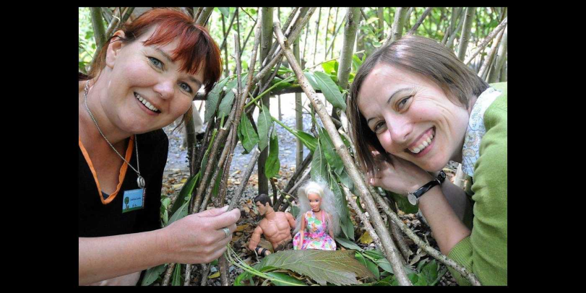 | Things you can find outside.  Or if you are housebound....the recycling stash.  Fabric.
4 | You might want to make some provisions for your stick person, such as furniture, or even a raft to sail away on.  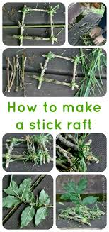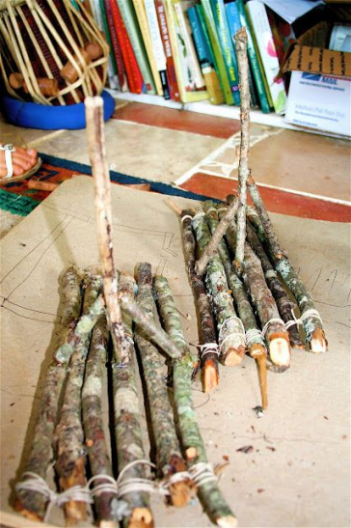 | Things you can find outside.  Or if you are housebound....the recycling stash.
5 | Does your ‘twig person’ have a family or friends. Why don’t you make them? | More from session 1.
6 | Adults cut off a long piece of string – the longer the better, and place the string outside somewhere (indoors if necessary). If the string passes over a variety of mini-environments, all the better. You can now take your stick person on an adventure along the string. What events will happen along the way? | String.
7 | Can you make a mini park for your stick person?  This might include a little swing (some wood tied to string hanging from a bush/tree/anything you have outside), or a seesaw (mini stump of wood with a flat piece over it) or a slide (sturdy leaf/bark/wood leant against a min stump).  You get the idea. | Things you can find outside.  Or if you are housebound....the recycling stash.
8 | This will hopefully have inspired you to think of some other ideas...try them out.

KS2
Session | Activity | Resources
For seven days, or longer if you wish.  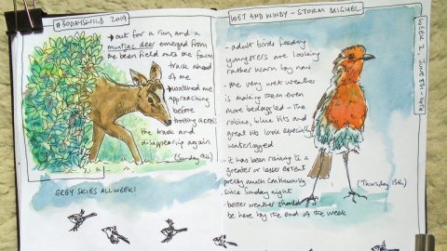  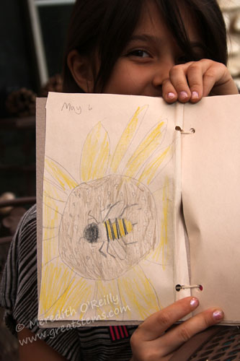 | Choose a place, either your garden, a local wild space or a view from a window in your home.  Spend time each day watching and noticing what birds or other animals are doing outside.  Make notes in a journal. Be sure to include:  What you saw, including details.  What time it was. This way you can notice any patterns.  You might also like to research any of the animals you notice. You could write up your findings and perhaps draw a picture.  For example, we have noticed over the last few days in my home that a magpie is collecting sticks from our garden and flying off to a tree in a neighbours garden. It must be making a nest. We will keep watching!  Even seagulls might make some interesting subjects to watch!  If you prefer, you could look each day and make a note of what leaves are opening, flowers appearing in a chosen place.  Record your observations each day, write up anything you find out and draw pictures.  Most of all, enjoy finding out about the wildlife in your chosen spot. | A notebook or some pages folded together. If you don’t have this, you could share with another person your observations or note them in a computer document.

