Mindfulness at home
The intention of these activities below is to give your child an opportunity to practise mindfulness. The benefits of mindfulness are many, but in particular, practising mindfulness can help with stress and anxiety. It is most appropriate to practise mindfulness from age 7 up (when the pre-frontal cortex in the brain is generally developed enough to be able to begin to self-regulate). However, there are lots of things younger children can do to help them towards this.
I am assuming that you have none or very little experience, so apologies if this is very basic. There are so many suggestions online if you are interested.
Mindfulness is being in the present moment, in a particular way, without judgement.
EYFS and KS1
1  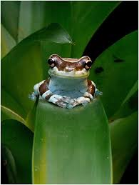 | Can you sit cross legged and imagine you are a frog. Yes, frogs can jump and make ‘ribbit’ sounds, but they can also sit very still. They are very aware of what is around them but they keep their eyes fixed. They don’t move, so that when a fly passes, they can catch it and enjoy a nice meal.  Try sitting still like a frog for a minute.
2 | Take a moment to think about a person in your life. What about them are you glad about? Can you talk to this person and tell them what you are appreciate about them? You might need to use the phone if you are allowed. A compliment is a lovely gift.
3  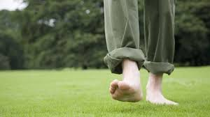 | Have a walk around your garden or a local wildlife area or your home if you can’t get out. Try to keep your mind on all that you are seeing, smelling, feeling and hearing.  When you finish your walk, can you recall at least one thing you:  saw, heard, felt or smelt?
4 | Ask a family member to talk to you about whatever they would like to for 1 minute. Your job is to listen carefully without interrupting.  Can you recall what was talked about, or did your mind wander? Not to worry if it did. That’s what our minds tend to do!
5  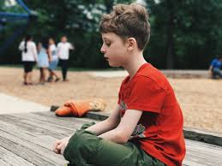 | Sit quietly outside and for 1 minute, just listen. What can you hear?
6  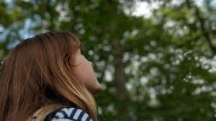 | Sit quietly outside and for 1 minute, try to keep your eyes on the same view. Can you notice the little movements of leaves, or branches. Do you notice any insects or birds?
7 | Lie down on the floor or a bed.  Close your eyes. Now, scrunch up your toes tightly for a few seconds and then let go of the muscles and let your toes relax. Move on to your ankles and do the same. Repeat for your knees, thighs, bottom, belly, arms, hands, shoulders and even your face.  Lie still for a minute or so with all your muscles relaxed. You are like a piece of spaghetti that had done from hard and uncooked, to soft and cooked. You are relaxed.
8  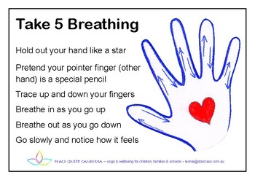 | Sitting cross legged, look at the palm of one of your hands. Now take the index finger of the other hand and put it at the bottom of your thumb on the opened-up hand.  As you breathe in, trace the outer side of the thumb with your index finger.  As you breathe out, trace the inside of your thumb with your index finger.  Keep repeating this so that you trace around all fingers, breathing in as you go to the tip of the finger, and out as you go back down the finger. Place all your attention on your breathing, and let your finger follow your breath rather that your breath following your finger.

KS2
1  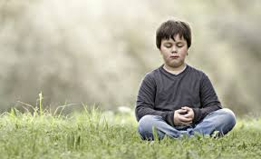 | Ground yourself.  Sit or lie down.  First, let your attention go to your feet on the ground if you are sitting, or the parts of your body in contact with the floor if you are lying. Become aware of any sensations. This brings your mind to your body, rather that it wandering off to other thoughts.  Now, notice what thoughts are passing across your mind. There is no need to react to them, just notice them. You might be worrying, or excited about something etc.  Next, notice what mood you are in. Our mood affects how we behave. It is helpful to be aware of your mood. You might be hungry and need food, cold and need an extra layer on, grumpy and snappy and end up in arguments, or happy and good fun to be around.  Finally, bring your attention to your breath. The cold air coming in through your nose as you breathe in, and the warm air as you breathe out. Maybe you notice your stomach, or chest move.  See if you can keep your attention on your breathe. Every time your mind wanders or a sound distracts you, just gently bring your attention back to your breathe. Try for a minute. You might be able to build up to 3 minutes.  Notice if your mood or behaviour changes after doing this.
2 | What mood are you in?  Draw a picture showing your mood. It might be of something or someone, or just colours, or very abstract shapes. That’s entirely up to you.
3  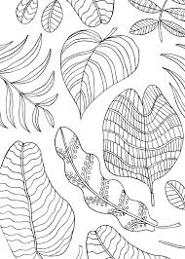 | Choose something to colour in. It can even be a picture you have drawn yourself.  You are going to colour in mindfully.  That means you will put all your attention on the activity. Notice the colours that appear, how it feels to hold the pencil. Keep an eye on the lines so that you don’t colour past.  It is better to do a little bit, rather than rush and not do it mindfully. You can always put it aside and go back to it.  If you don’t have coloured pencils, you could use a pen or pencil and either use patterns or shade.
4  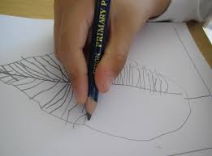 | Go and pick a leaf/flower/stick or anything natural that interests you from outside.  Now, make an observational drawing.  This means you are drawing what you see, not what you think it should look like. If an insect has nibbled at the leaf, draw this in.
5 | Mindful eating.  For a few minutes, while eating something, do so mindfully.  Look at the food before you put it in your mouth.  Smell the food.  How does your body feel just looking at the food?  Once you put it in your mouth, hold it on your tongue for a moment.  Then, slowly move the food around. What are the flavours.  Bite carefully down on the food, how does it taste now? Does it make a sound?  Chew carefully
6  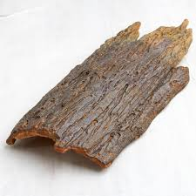 | Mindful touching practice.  Go outside and find five natural items you think have interesting textures (will feel interesting). Sit down with the items.  Choose one and with your eyes closed, feel it in your hands.  Try this with the other items. Are you surprised by how any of the items felt?
7 | Nurturing a plant.  If you have a house plant, why don’t you take over looking after it? Make sure it has what it needs to thrive: water, dust free, the right light. You might even want to talk to it.  If you don’t have any house plants, you could always take an interest in a plant in your garden/courtyard or road. It could be a dandelion.
8 | Help with the washing up and do it mindfully. Put all your attention onto the feel of the cloth, pans and cups etc. Notice the sounds. Notice how you use your body to stretch to put plates away.

