BOY AND MONSTER
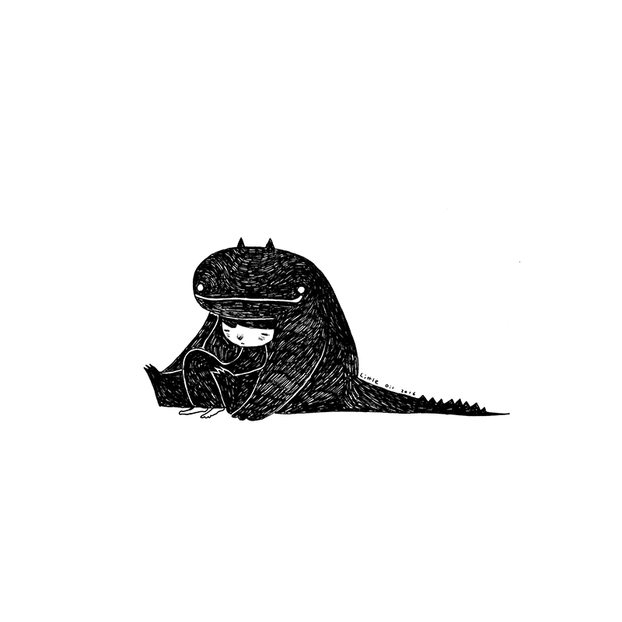

Credit: Little Oil

- What is the boy doing? How is he feeling? How do you know?
- Is the monster good or bad?
- Does the boy know the monster well?
- Is the monster real, or a representation of something?
- Why do you think Little Oil left so much white space around the boy and the monster?
- Imagine that the monster represents a feeling. Which feeling could it be and why?
- What does sadness feel like? What does fear feel like? What does anxiety feel like? Draw a picture of these feelings as if they were characters or monsters. Once you’ve drawn your character, what might you say to it?
- What does sadness feel like? What does fear feel like? What does anxiety feel like? Try to describe what feelings you have in your body when you feel this way. You might want to draw a diagram and label it, or draw on it to show the different physical changes that happen to you.
- Are these feelings good or bad?
- What do you do when you’re feeling sad/scared/anxious/worried? What could you do to help yourself? What could others do to help you?
- Some useful phrases for adults working with or supporting an anxious child: http://www.gozen.com/49-phrases-to-calm-an-anxious-child/

