When | What I/we did
Morning
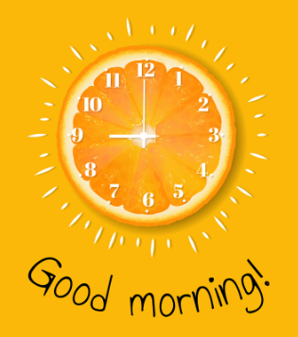
Afternoon
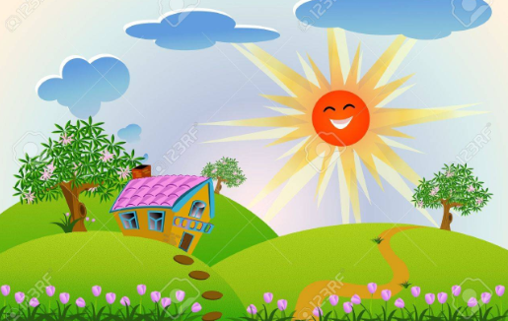
Evening
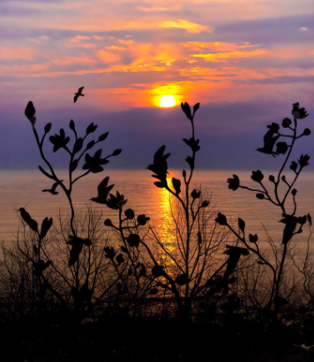
The best part of the day was when

