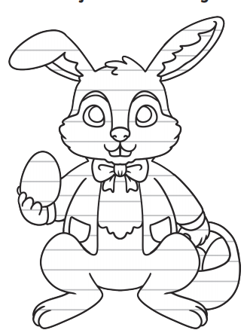
Dear _______________

Thank you so much for
_____________________________________
_____________________________________
_____________________________________
_____________________________________
I especially liked
_____________________________________
_____________________________________
_____________________________________
_____________________________________
_____________________________________
I hope that you have a good rest from giving everyone Easter eggs. Make sure that you have fun and rest. I have some ideas to help you...
_____________________________________
_____________________________________
_____________________________________
_____________________________________

Lots of love from

