Maths EYFS
Share the WALT (We Are Learning To) with the children so they know what they are trying to learn each day. Complete the sessions in order and let me know how you get on with them. Have fun!
Miss Pittas

Session 1  WALT: recognise a number of objects without counting them  Activity: Roll a dice ad say the number of spots without counting them. Can you do this with two dice? Look around your garden, in your kitchen or go for a walk to find a small number of objects together and talk about what you can see e.g. use bottle tops, pasta shells, small stones, daisies on the grass  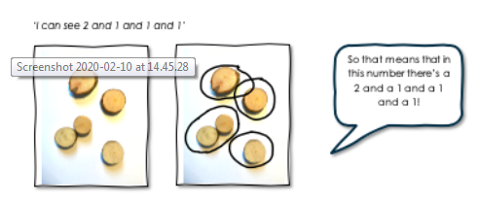 | Session 2  WALT: recognise teen numbers  Activity: Look at the teen numbers 11-19, Reinforce that the first digit means one ten, not one. Go and collect that number of small objects e.g. soft toys, toy vehicles, pieces of cutlery etc. Talk about rearranging the objects in different ways to show the same number.  Challenge : can you use chalks or sticks to create two large ten frames outside?
Session 3  WALT: understand the term double  Activity: Look at objects that show doubles e.g. dominoes, egg boxes, dice. Explain it means ‘twice as many.’ Can the children show you doubles using everyday objects? E.g. toy cars, forks, cups etc If you have a set of dominoes can you find all the dominoes? Draw or paint different ways of making doubles  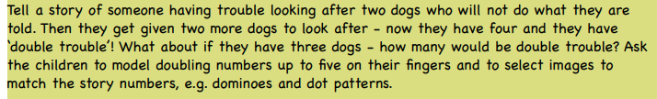  Link to a website to support you in this area of learning:  Use Youtube to read the story by Allan Alhberg This is the story of Alison Hubble | Session 4  WALT: understand the term double  Activity: Continue with working on understanding the term double. Hide two of each number (1-20) around the room or outside and find the matching pair to make it a double. Use small bricks e.g. duplo to make towers of numbers up to 20 and then make a double to match. Draw a butterfly or ladybird and double the spots:  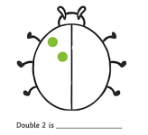  Link to a website to support you in this area of learning:  BBC Numberjacks Series 2 Double Episode 9 on Youtube
Challenge:  Place the teen numbers up around the garden or outside space at child’s height then use a nerf gun or water spray/fly swat to squirt the chosen number. Can you squirt one more or one less?  Play hopscotch using teen numbers.  Play board games that involve dice e.g. snakes and ladders | Glossary of terms  Ten frame : one picture in each square so to make a teen number you will need two of these e.g. 