EYFS Phonics Lessons
Week Beginning 14.4.20
This week we will recap some sounds that we have recently learned in class. They are all called digraphs. This means that they have 2 letters in them but only make 1 sound when we say them. (The children use the words ‘digraph and sound’ all the time so don’t be afraid to use them when you talk together.) The phonics sessions have 3 parts to them. Watch – Play – Do. Tell your child which sound you are looking at, watch the youtube clip together then have a go at the activity at the end of the lesson. Sometimes the ‘Do’ will be a writing activity and sometimes a game or a challenge. You could try doing it more than once in a day but, above all, have fun together.
Let me know how you get on and please do ask me if you are not sure!
Miss Pittas
Day 1 | Day 2 | Day 3 | Day 4
oa  This sound is found in words like:  boat, coat, toad  Watch:  https://www.youtube.com/ watch?v=M8nGaspuWAQ  This will help you to sound out words with oa in them. Feel free to watch more than once. Encourage your child to sound them out too.  Play:  Picnic on Pluto on www.phonicsplay.co.uk (free to use)  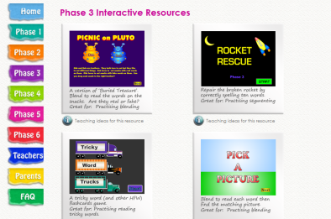  Choose Phase 3 and then click on +oa. The game will start automatically.  Do:  Phonics EYFS Day 1 activity | oo  This sound is found in words like:  book, look, food, poo  Notice that it makes a long sound in food but a short sound in look.  Watch:  https://www.youtube.com/ watch?v=ONgqoexO8gY  This will help you to sound out words with oo in them. Feel free to watch more than once. Encourage your child to sound them out too.  Play:  Buried Treasure on www.phonicsplay.co.uk (free to use)  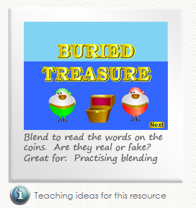  Choose Phase 3 and then click on +oo.  Do:  Phonics EYFS Day 2 activity | ar  This sound is found in words like:  farm, star, harp  Watch:  https://www.youtube.com/ watch?v=lLFON8qBZsE  This will help you to sound out words with ar in them. Feel free to watch more than once. Encourage your child to sound them out too.  Now watch:  https://www.youtube.com/ watch?v=NEvlotQZf50  Play:  Picnic on Pluto on www.phonicsplay.co.uk (free to use)  Choose Phase 3 and then click on +ar. The game will start automatically.  Do:  Choose a game to play on www.phonicsplay.co.uk  Write some of the words you have learned in chalk, using your finger on someone’s back, in the air, with a paint brush. | or  This sound is found in words like:  torch, fork, pork  Watch:  https://www.youtube.com/ watch?v=0TKWxjU0UgQ  This will help you to sound out words with or in them. Feel free to watch more than once. Encourage your child to sound them out too.  Play:  Buried Treasure on www.phonicsplay.co.uk (free to use)  Choose Phase 3 and then click on +or.  Do:  Choose a game to play on www.phonicsplay.co.uk  Write some of the words you have learned in chalk, using your finger on someone’s back, in the air, with a paint brush.

