YEAR 1 Phonics Lessons
Week Beginning 14.4.20
This week we will recap some sounds that we have recently learned in class. They are all called digraphs. This means that they have 2 letters in them but only make 1 sound when we say them. (The children use the words ‘digraph and sound’ all the time so don’t be afraid to use them when you talk together.) The phonics sessions have 3 parts to them. Watch – Play – Do. Tell your child which sound you are looking at, watch the youtube clip together then have a go at the activity at the end of the lesson. Sometimes the ‘Do’ will be a writing activity and sometimes a game or a challenge. You could try doing it more than once in a day but, above all, have fun together.
Let me know how you get on and please do ask me if you are not sure!
Miss Pittas
Day 1 | Day 2 | Day 3 | Day 4
ir  This sound is found in words like:  first, stir, dirt  Watch:  https://www.youtube.com/ watch?v=7ta_KKUU-98  then:  https://www.youtube.com/ watch?v=TKp92vSrRwA  Play:  Picnic on Pluto on www.phonicsplay.co.uk (free to use)  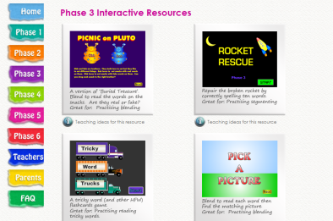  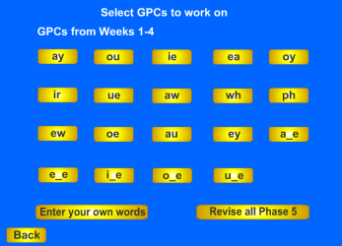  Choose Phase 5 and then click on ir.  Do:  Year 1 session 1 ‘ir’ word search | ue  This sound is found in words like:  glue, blue, Tuesday  Watch:  https://www.youtube.com/ watch?v=fLrAGcK26s4  This will help you to sound out words with ue in them.  Play:  Buried Treasure on www.phonicsplay.co.uk (free to use)  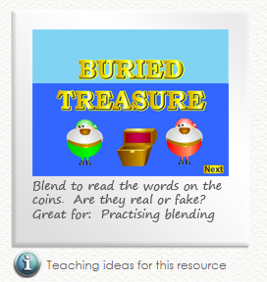  Choose Phase 5 and then click on ue.  Do:  Make a list of real words using the ‘ue’ sound. Show your grown-ups how you can make a list of alien words (That’s non real words to you grown ups. These help us to use our phonics really well.) Write your words in your book. Can you trick a grown-up with your alien words? | aw  This sound is found in words like:  strawberry, awful  Watch:  https://www.youtube.com/ watch?v=finOGW5MCCs  Now watch:  https://www.youtube.com/ watch?v=GHpyJ5svbgM  try to focus just on the ‘aw’ pattern.  Play:  Picnic on Pluto on www.phonicsplay.co.uk (free to use)  Choose Phase 5 and then click on aw.  Do:  Choose a game to play on www.phonicsplay.co.uk  Write some of the words you have learned in sentences. No cheating… a sentence as short as this (I like strawberries) can always be made even better using words like ‘and’, ‘so’ and ‘because’. Record your sentences in your book.  Write at least 5! | ew  This sound is found in words like:  stew, few, new  Can you notice that ew makes a slightly different sound in the word ‘grew’ than it does in the word ‘news’  Watch:  https://www.youtube.com/ watch?v=GJL84QOnGIA  Now watch:  https://www.youtube.com/ watch?v=ZojmFjUAGh4  Play:  Buried Treasure on www.phonicsplay.co.uk (free to use)  Choose Phase 5 and then click on ew.  Do:  First:  Phoneme spotter sheet session 4 ‘ew’  Now:  Choose a game to play on www.phonicsplay.co.uk

