Reading at home in Kilminorth Class.
(Health warning: Please bear with this long message. It’s my hope that you can use this information to set up some fab reading sessions with your children. They can be set up so that you don’t need to be there all of the time and the children will love the books.)
For those of you (adults that is) who have braved a Joe Wicks work out in the last few weeks, you will know all too well how painful the 30 minute session was. Those muscles that you forgot existed suddenly said ouch!
Reading can be a little bit like for our children. The less they do it, the harder it is. With this in mind, I have looked into a resource that I previously recommended in my blog.
www.oxfordowl.co.uk
Follow these instructions to find books that are suitable for your children. I am not allowed to post personal levels online due to data protection but, if your child cannot remember their level, please message me and I can let you know.
Here’s what to do:
Firstly, click on the ‘Join Us’ button and subscribe as a parent. It is free and you can only access the books if you subscribe. Once you do, the following instructions can be followed.
- Type in the website. www.oxfordowl.co.uk
- Choose Oxford Owl for Home
- Click on the ‘Browse e books’ in the Free e book library box
- Scroll down and look at the right hand column
- ‘Browse by Oxford Level’
- Click on the level your child says they are
- Choose a book then click ‘Read e book’ when the little pop up appears. This takes you to the front cover.
- At the bottom of the screen you will see forward and backward tabs. Use these to turn pages.
- Some books have ‘Play Activity’ buttons at the top of the screen. After reading the book, encourage your child to have a go at these. They are a great way to see if your child has understood the book. It isn’t a memory test. Let the children look through the book for the answer if they need to.
Please say if I can help with this. The children will love reading online... promise!
Here some photos to help you.
1: 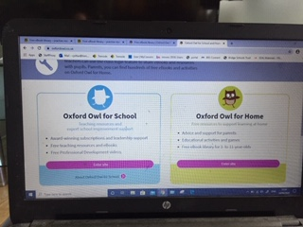
2: 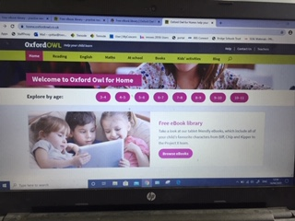

3: 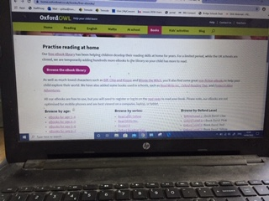
4: 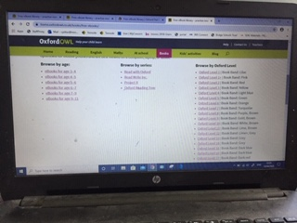
5: 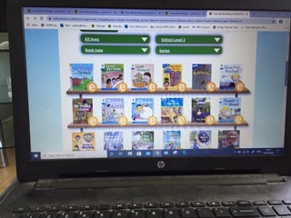
6: 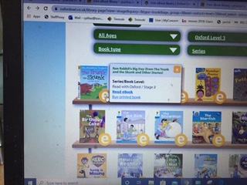
7: 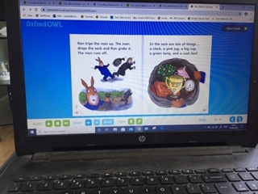
8: 