English Planner
Week Beginning 20.4.20
Year 1 | Day 1  Reading  Log in to www.oxfordowls.co.uk .  Read one of the books below and have a go at the ‘Play Activity’ that goes with them. I have included a book for 3 levels of difficulty. A Red level, a Yellow level and a Light Blue level  Please read the notes for parents (See arrow below) as they tell you a little more about the book and help you to know what to typically expect as your child has a go at reading with you. 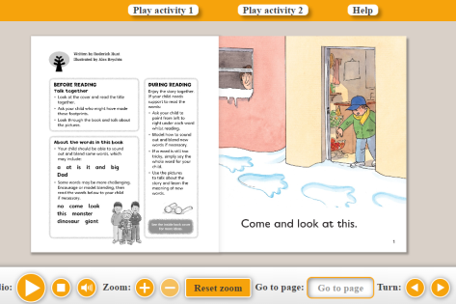  Red Level Book: 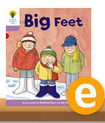  Yellow Level Book: 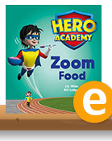  NB: This book does not have Play Activities. Reading and talking about it throughout the day is enough.  Light Blue Level Book: 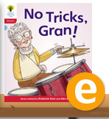 | Day 2  Describing a Character  Go to:  https://www.bbc.co.uk /iplayer/group/p06vkmht  Click on The Gruffalo.  Watch the clip then talk about all of the words used to describe him in the story.  Draw a picture of the Gruffalo in your exercise book. Write a description of the Gruffalo underneath it. Your description needs to include what he looks like and what he is like as a character.  Be sure to see what a good one looks like by opening the ‘Year 1 and Year 2 Example Character Description for the Gruffalo’ | Day 3  Food Menu  Go to:  https://www.bbc.co.uk /iplayer/group/p06vkmht  Click on The Gruffalo and watch the clip again. This time, look out for all of the food mentioned. The mouse talks about it all the way through the book.  Use what you discover to make a menu for a Gruffalo-style café. See: ‘Year 1 and Year 2 Blank Menu for Gruffalo’. Draw pictures and decorate to make your menu fit for putting in the finest cafes in Cornwall.  Extra Fun: Why not visit the website and play! https://www.gruffalo.com/join-in/food
 | Day 5  Talk and Play Day  Find a board game to play. Read the rules together and talk about how you will play together. Why not get the children to go and invite different people at home to play too? | If you have any questions, please do ask. I am an email or Classlist conversation away.  Miss Pittas

