EYFS and Year 1 Phonics Lessons
Week Beginning 20.4.20
The phonics sessions have 3 parts to them. Watch – Play – Do. Tell your child which sound you are looking at, watch the youtube clip together then have a go at the activity at the end of the lesson. Sometimes the ‘Do’ will be a writing activity and sometimes a game or a challenge. You could try doing it more than once in a day but, above all, have fun together.
Let me know how you get on and please do ask me if you are not sure!
Miss Pittas
Day 1 | Day 2 | Day 3 | Day 4 and 5
ur  This sound is found in words like:  Burp, turn, hurt  Watch:  https://www.youtube.com/ watch?v=9354FVIi0nM  This will help you to sound out words with ur in them. Feel free to watch more than once. Encourage your child to sound them out too.  Play:  Picnic on Pluto on www.phonicsplay.co.uk (free to use)  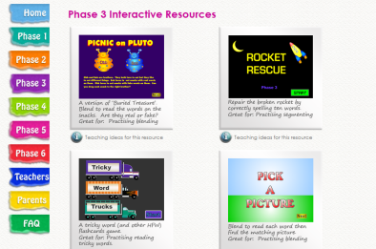  Choose Phase 3 and then click on +ur. The game will start automatically.  Do:  Make a list of ‘ur’ words in your book. Can you draw a picture to go with them? | ow  This sound is found in words like:  Cow, how, owl  (There are 2 ways to say ‘ow’ the children learn the ow as in crown sound first.)  Watch:  https://www.youtube.com /watch?v=9Ph6nnHrVwY  Sound out the words with your grown-up  Play:  Buried Treasure on www.phonicsplay.co.uk (free to use)  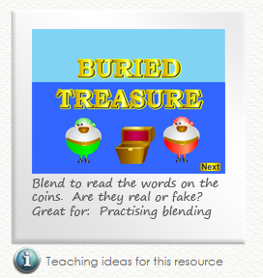  Choose Phase 3 and then click on +ow.  Do:  Play another game of your choice on Phonics Play. Make sure you sound everything out as you play today. | oi  This sound is found in words like:  oil, oink, boil  (There are 2 ways to write ‘oi’ the children learn the oi as in coin sound first and not the oy as in toy.)  Watch:  https://www.youtube.com/ watch?v=Z-0wWdE-Ezg  This will help you to sound out words with oi in them. Feel free to watch more than once. Encourage your child to sound them out too.  Play:  Picnic on Pluto on www.phonicsplay.co.uk (free to use)  Choose Phase 3 and then click on +oi. The game will start automatically.  Do:  Phonics EYFS and Year 1 oi sheets  NB Answer sheets are included. Not all pictures are meant to be ones that have the sound ‘oi’ in them. Children only colour and write the ones that do. | Practice the sounds of the week by watching the videos and playing some of the games again.  Can the boys and girls read and write them? Can they think of words with the sounds in?

