Maths for Year 1.
Week Beginning 20.4.20
For Maths sessions, please go to www.whiterose.co.uk.
1: Click on the Home Learning tab and the screen should look like this:
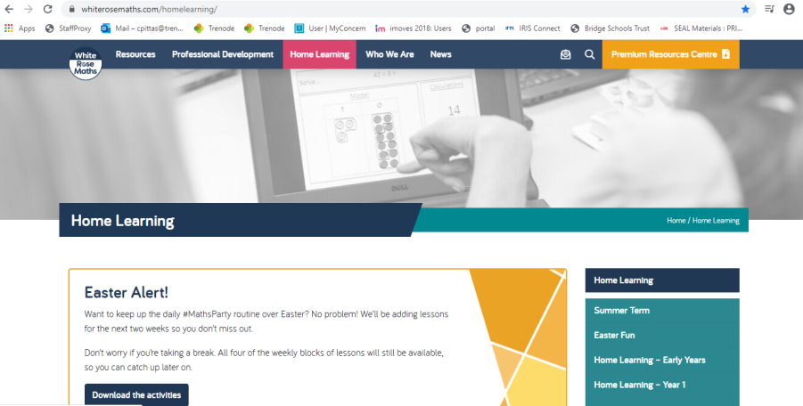

2: Then click on ‘Home Learning Year 1’ (see arrow)

3: Then click on Summer Term Week 1:
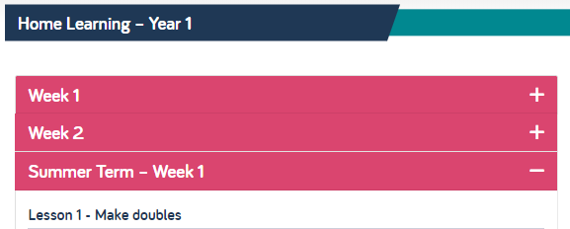

You will see that under this are 5 days of lessons.

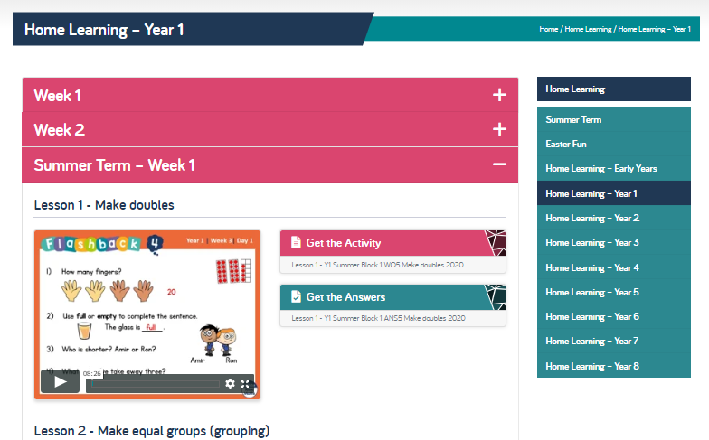

For each day this week, select the day, listen to the teaching recording and video with your child. Click on the activities and have a go. Maths is everywhere and it’s meant to be fun. YES, FUN!! I hope you like these sessions.

In the table below, I have any extra notes for the session.
Please do let me know how you get on. Why not add some of what you do to our Facebook page or email some photos?

THERE IS NO NEED TO PRINT OUT THE ACTIVITIES. If it will help you then please do print them. Otherwise, ask the children to write the title of the week (In this case Summer Week 1) with the Day’s number next to it.

Day 1 | Day 2 | Day 3 | Day 4 | Day 5
Listen to and watch the clip.  Follow the instructions in the session. Be warned, when she says to pause the clip, she means it. The answers come closely afterwards.! | Listen to and watch the clip.  After completing the activities, can your child spot what is an equal group? Can they find things around the house to make into one? | Listen to and watch the clip.  Sharing is really important. We all know what it’s like when something isn’t fair. Today, after or before completing the activities, take it in turns on sharing things out – just for fun. Can you trick anyone by sharing and not doing it fairly? What things are best shared fairly? (I know that my brother, sister and I were pretty good at recognising ‘fair’ when it came to who had the most chips or crisps on our plate as children…) | Listen to and watch the clip.  Make the screen big and pause as soon as it asks you how many are in the 10 frame at the top. It is talking about the little picture at the side of the screen. The top right one. (answer is 15)  Answer the questions 1-4 before pressing play again. It gives you the answers very soon!  A little bit more:  Try making half around the house. Can you use your finger to find half of your bed or kitchen table (if you have one)? Try breaking a biscuit into exactly half. Remember, it is only half if both sides are EXACTLY the same. If one piece is bigger than the other, it is not a half; just split into 2 pieces. | Listen to and watch the clip.  Follow the on screen instructions for this session.
You will notice that I haven’t put up resources for the learning this week. All of the resource sheets you need are on the website. Take a look below to see where they are:
