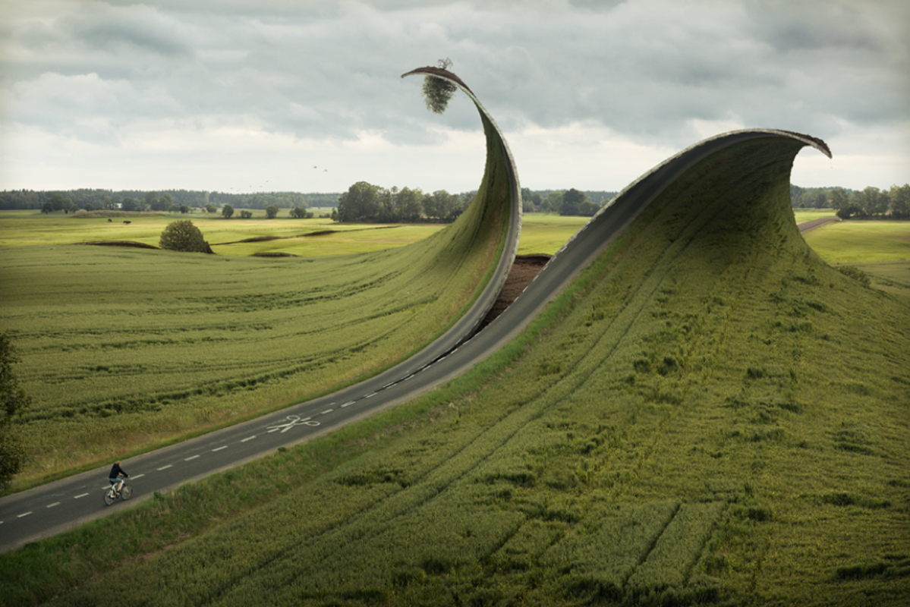

Reshaping the world

Question time!
Who is controlling the scissors?
Why do you think the World is being re-shaped?
If you could change the World what would you change?
What would you keep the same?

Perfect picture!
Can you draw what the world will look like once the outer layer has been cut away by the scissors?

Story starter!
Snip..Snip…Snip…The scissors began to tear the countryside apart. Towns, fields, rivers and oceans. Forests, valleys, mountains and lakes. The world began to unravel piece by piece, strand by strand.
This was to be a new beginning. What would this new world look like?

Sentence challenge!
Can you use adverbs in your writing to describe how something is done?
Can you use adverbs before nouns?
Can you use adverbs after nouns?
e.g. Viciously, the scissors snipped their way through the endless fields.
The scissors methodically snipped their way through the abandoned countryside.

Sick sentences!
These sentences are ‘sick’ and need help to get better. Can you help? Could you add an adverb?
The scissors cut. The ground started to move. A man was cycling on the road. He was scared.

