FIRST FLIGHT

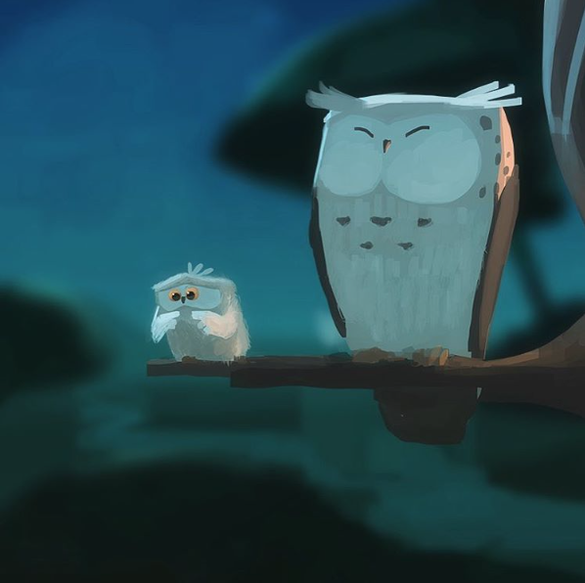

Credit: Goro Fujita

- How are the owls related?
- Which owl is about to take its first flight? How do you know?
- How does the young owl feel about flying?
- What might it be thinking? Add a thought bubble to the picture.
- Is the older owl worried?
- What advice might the older owl give to the younger one?
- Think of the first time you did something new. How did you feel about it? What emotional journey did you go on? Plot your feelings on a graph.
- If trying new things is scary, does that mean you should never try them?

