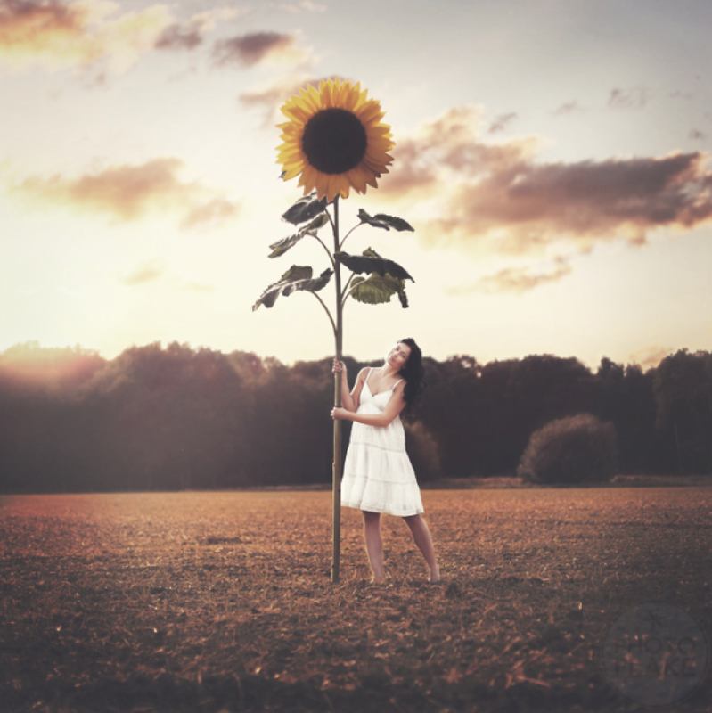

The Sunflower
The Sunflower

Question time!
Where will the magic sunflower take Lucy?
If you were Lucy, would you hold on to the sunflower or let go?
How did Lucy acquire the seed?

Perfect picture!
Imagine what the sunflower will look like the next day. Draw or describe what you have imagined.

Story starter!
Lucy had only planted the seed minutes earlier. Now, it was growing in front of her eyes! The earth began to tremble as the sunflower grew thicker and thicker, taller and taller.
With no sign of stopping, the plant seemed to be reaching up towards the sun. She held on tightly, not daring to wonder where she might be swept off to…

Sentence challenge!
A parenthesis is a word or a phrase put into a sentence to give it more information.
Sometimes a parenthesis is in italics, sometimes it is in (brackets), sometimes there is a dash – and sometimes it has ‘inverted commas’ around it.
Parentheses are used to:
Explain what a difficult word means.
Show someone’s thoughts
Add extra information to help the reader
Emphasise a point
Can you use brackets to add extra information?
E.g. The sunflower (which was growing at an incredible speed) cause the earth around it to tremble.

Sick sentences!
These sentences are ‘sick’ and need help to get better. Can you help?
The girl grabbed on the sunflower. The plant went up into the sky.

