Maths for Year 1.
Week Beginning 20.4.20
For Maths sessions, please go to www.whiterose.co.uk.
We are now on: Summer Term – Week 2
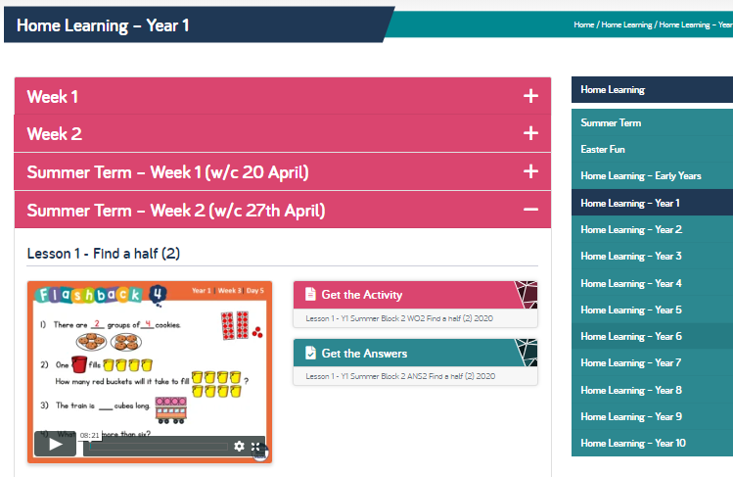
Day 1 | Day 2 | Day 3 | Day 4 | Day 5
WALT: Find half  Listen to and watch the clip. | WALT: Find quarter  Listen to and watch the clip. | WALT: Find quarter – session 2  Listen to and watch the clip. | WALT: Problem Solving  Listen to and watch the clip. | Friday Maths Challenge  At time of writing, this week’s challenges are not on the White Rose website. If this works in the same way as last week, children in Y1 can be expected to have a go at questions 1 and 2. The website gives you this information in the ‘Get the Challenges’ section of the page. As usual, if you have any questions, please send me a message and I will do my best to help.
You do not need to print the resources as you can write the answers in your exercise book BUT, if you can print, it will help with being able to draw and find the fractions shown. NB I can arrange for copies to be printed but you need to A: Tell me you need them and B: Be able to get to our hub school at Looe Primary to be able to collect them.

