MEDITATION

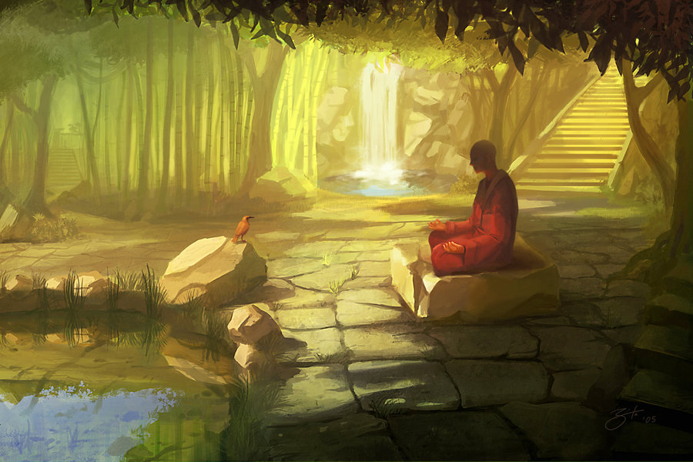

Credit: Goro Fujita

- Where is this?
- Describe the setting. What can you see, hear, feel and smell?
- How does this setting make you feel?
- What is the person doing? Why?
- Who is it?
- Why did they choose to meditate here?
- What is meditation?
- Why do people meditate?
- What do you do to help you feel calm?
- Where do you feel the calmest?
- Are you good at recognising and managing your emotions? What are you good at and what do you struggle with?

