Maths for Year 1.
Week Beginning 11.5.20
For Maths sessions, please go to www.whiterose.co.uk.
We are now on: Summer Term – Week 4
This week, the resources have had the biggest change since the launch of the White Rose Home Learning section began. Our lessons will be slightly different this week but we hope to get it back to the way you have become familiar with by next week. (I might be able to get it sorted very early on in the week and if I can, I will let you know.)
BIGGEST CHANGE:
Instead of simply being able to click the resource sheet for your activities, you will need to click the bbc button. I will show you how to get Monday’s activity but be aware that each day will be released on a day to day basis (unlike the option of being able to download every lesson as we have before).
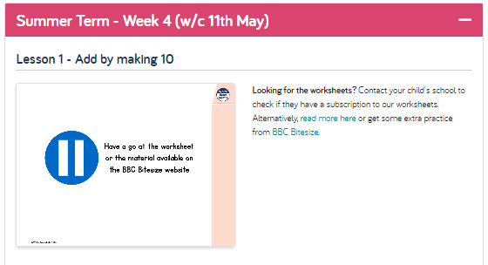 1) Click the BBC Bitesize button: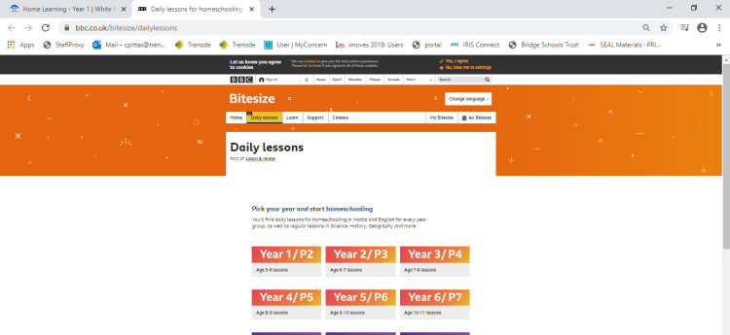
2) Then click on Year1:
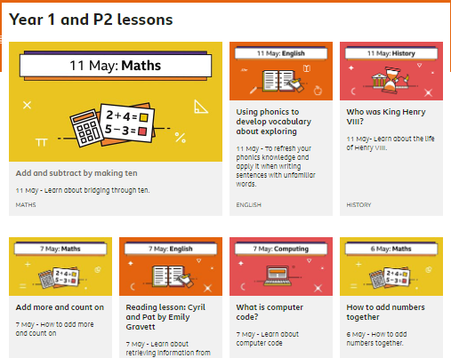 3) Then 11th May Maths. 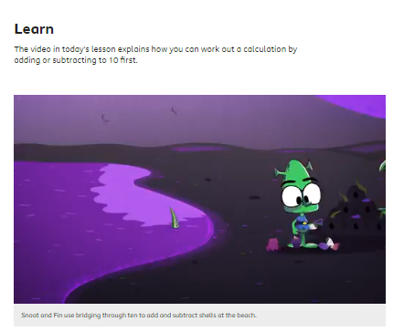
4) Feel free to watch the video clip but you can just scroll down to the activities…
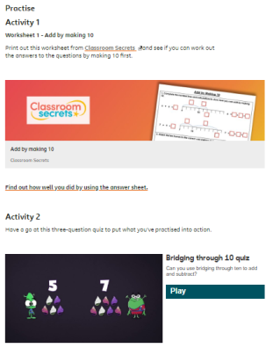 5) Clicking on the Classroom Secrets Activity brings up a pop up for the Maths activity. In this case, the second activity is a game.

Day 1 | Day 2 | Day 3 | Day 4 | Day 5
WALT: Add by making 10.  This session is going to seem like it is too easy for the children. Please don’t let them tell you they know it. They will need to answer all the questions on the video teaching section. This session will be vital in their understanding of adding within 20 (tomorrow’s session) and adding within 50 and 100 (these being Y1 expectations). Being able to do the skill today and to see the pictures in the video will help them always in Maths. It is the foundation of any addition and subtraction they will do from now until Y6.  See note in general section above for this week’s resource sheets. We will have a better solution for resource sheets for next week’s sessions. | WALT: Subtract within 20.  Bear with the teaching video. Ask your children to answer each question as it appears on the screen. We have not use the number line extensively in class so this is a great chance for them to see how it works.  What is great about this teaching clip is the way it embeds the pictures into your child’s mind. If your child is saying it is easy, that’s a good sign. (But not a reason to not keep with the teaching!) | WALT: Add and subtract worded problems.  View the clip and answer the questions as they are given to you. Shorter clip today. | WALT: Compare number sentences  View the clip and answer the questions as they are given to you. Shorter clip today. | 2 Activities today!  1: Complete the Maths Friday sheet in blog resources. These use this week’s skills. There are 3 levels of challenge with 3 questions on each sheet.  1: Easier (All children to do this)  2: Expected Standard (All children to do this also)  3: Greater Depth (We have a few in our class who will be able to do this. Have a go and see how you do.)  Activity 2: White Rose Maths Challenge (on website, as usual)  Friday Maths Challenge  Take a look at questions 1 and 2. Can you extend yourself to question 3 or even 4?
You do not need to print the resources as you can write the answers in your exercise book BUT, if you can print, it will help with being able to make more connections in your thinking.

