EYFS and Year 1 Phonics Lessons
Week Beginning 11.5.20
These sounds recap some phase 3 learning. Be sure to let the children sound out as they read. They know what robot arms or phonic fingers are so ask them to show you and be your phonics teacher.
Phonics is often the thing parents don’t understand as well as the children do (it was so long ago that we were taught to read, wasn’t it! ). Let them take the lead. Remember, if they say it is easy, get them to do all the activities to PROVE it!
Day 1 | Day 2 | Day 3 | Day 4 | Day 5
ear  This sound is found in words like:  Tear fear dear  Watch:  https://www.youtube.com/ watch?v=6-EJF4A-sO0  This will help you to sound out words with ear in them. Feel free to watch more than once. Encourage your child to sound the words out too.  Play:  Select a game from phonics play www.phonicsplay.co.uk to practice the ‘ear’ recognition. EG Picnic on Pluto, Dragon’s Den, Buried Treasure. Be sure to select the sounds needed like you have in previous games.  Do:  ‘ear’ wordsearch in the resources.  (NB there are 2 versions. 1 with all the words given and one with just the hidden letters. The challenge is children finding all ear words by searching them.) | air  This sound is found in words like:  hair, pair, chair  Watch:  https://www.youtube.com/ watch?v=uZHKK9jnfFQ  Sound out the words with your grown-up  Play:  Buried Treasure on www.phonicsplay.co.uk (free to use)  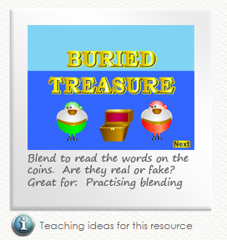  Choose Phase 3 and then click on +air.  Do:  ‘air’ reading activity in the resources. This is simply a list of real and not real words. No need to print them just ask your child to read each word.  Expect your child to sound out the words and each time they come to the letter patter ‘air’ they must say the sound and not the individual a, i and r.  Stick with this and make sure they read them all, even if you have to come back to them later. | ure  This sound is found in words like:  Pure sure secure  The first thing to notice about this sound is that it sounds slightly differently depending on where you are in the country. Imagine, my Welsh upbringing puts the stress on the ‘u’ (making it sound like ‘yu’) so… don’t worry if you hear the sounds slightly differently in both the video clips. I chose 2 different ones on purpose and for this reason. Say the words how you do and as long as the children can read and say it in words, I would not worry about it.  Watch:  https://www.youtube.com/ watch?v=YwCzf71flBA  Also watch: https://www.youtube.com/ watch?v=IK8m-5JQmso  Play:  Picnic on Pluto on www.phonicsplay.co.uk (free to use)  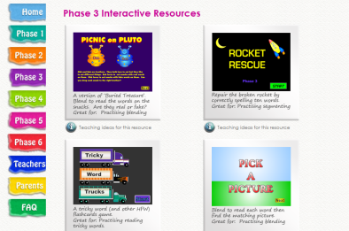  Choose Phase 3 and then click on +ure. The game will start automatically.  Do:  Play another phonics game of your choosing today. Try to ensure that ‘ure’ is in it. | er  This sound is found in words like:  Mixer, tower, hammer  Watch:  https://www.youtube.com/ watch?v=Taa3ANEyN_Y  Be sure to sound out each word. If this is easy to do, ask your grown up to say an ‘er’ word and you try to write it down without looking.  Do:  Spot the ‘er’ words in the ‘The Mermaid in the River’ sheet.  Children should be able to read all the words on this sheet. Have a go at reading it with the children only helping after they have been asked to try using their phonics sounds to help them read. Colour in the words with the ‘er’ sound. | Consolidation of all this week’s sounds  Watch any clips and revisit any activity the children have struggle with this week THEN  Complete the  ‘ear, air, ure,er’ game in the resources.  (simply put each picture where it has the sound within the word – a ‘chair’ is put on the ‘air’ sheet.)

