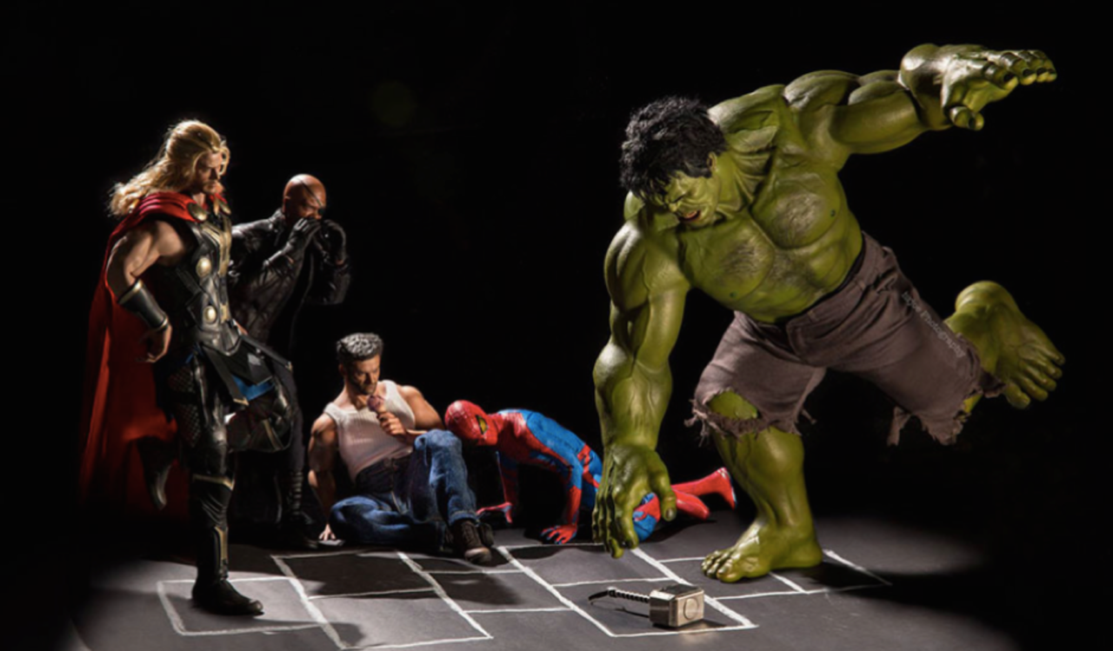

The Vacation

Question time!
If you could go anywhere on holiday where would it be?
Who would you take with you?
Which of the superheroes would you most like to have on holiday with you?
What activities or sports do you think each of the characters would be good at?
Which of the characters would you most like to be? Why?

Perfect picture!
Can you draw or describe one of the superheroes doing an activity that you like doing?

Story starter!
Everyone needs a vacation every now and then. Superheroes are no different.
Can you write a diary or story in the 1st person from the perspective of one of the characters? You could describe where you go on vacation and what activities you do. Does it all go to plan? Do you always get on with your fellow superheroes?

Sentence challenge!
Insert the inverted commas into the sentence below.
Did we have to bring him along? Spiderman muttered under his breath. He always breaks things.
Can you use speech in your writing today? Remember to use inverted commas.

Sick sentences!
These sentences are ‘sick’ and need help to get better. Can you help? Could you add an adverb?
Hulk had big arms and a big chest. He wore trousers.

