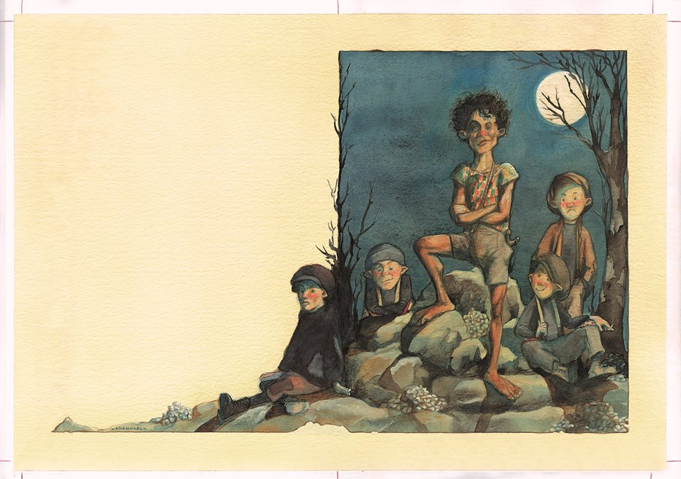

Credit: Nikolas Andrikopoulos

BULLIES
Without sharing the title:
- What do you think of these boys?
- Could you make friends with them? Would you?
- Imagine you are stood in front of them: how does their body language make you feel?
- Give this image a title. Explain your choices.
Share the title of the image:
- Do these boys look like bullies? Why/why not? Do all bullies look and act the same?
- Do you think they all join in? If they just watch, are they still bullies? What is a bystander? What is peer pressure?
- What makes a good friend?
- What is bullying?
- Are bullies always boys?
- How old are bullies?
- How can you identify a bully?
- Are some people more likely to be bullied? Who? Why?
- Have you ever been bullied? Have you ever witnessed bullying?
- What can you do if you’re being bullied? How can bullying be tackled?

