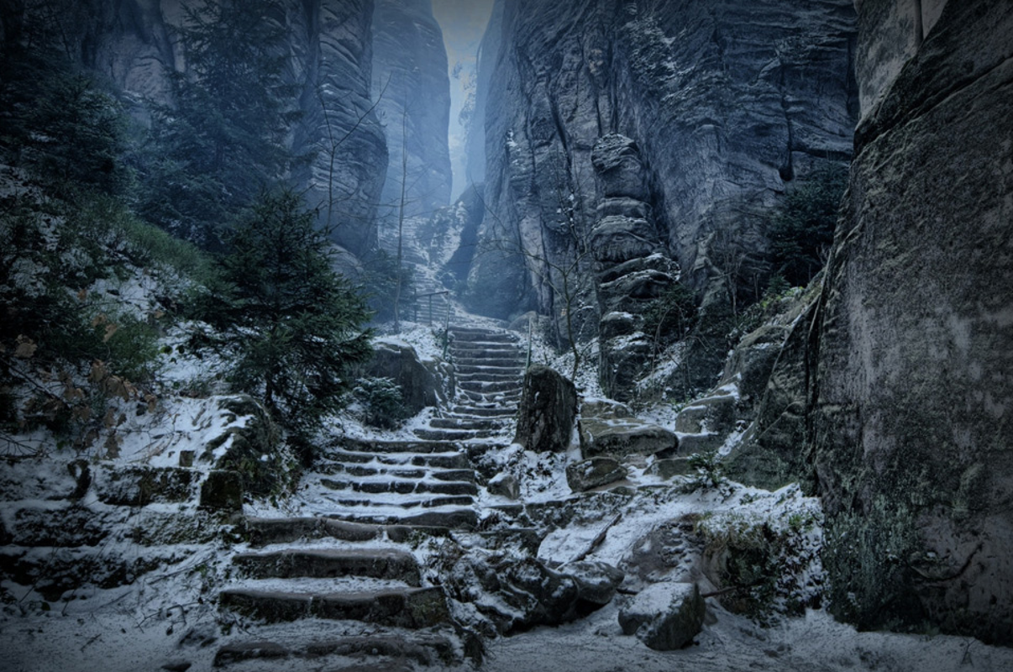

The Mountain Pass

Question time!
Who is the adventurer in the story?
Can you think of a good name for him?
Why does he want to climb High Hrothgar?
Why are people afraid of the mountain?
What do you think awaits him at the top?
What might the adventurer be carrying with him?
What would you take with you on an expedition such as this?

Perfect picture!
Can you draw what the adventurer looks like? Think carefully about what kind of person he might be, and what he might be wearing/carrying.

Story starter!
The mountain of High Hrothgar had stood proudly for thousands of years, casting a solemn shadow for miles around.
Few dared to venture close to its base, let alone scale its heights, fearing what awaited at the summit. For one brave adventurer, the folk lore surrounding the mysteries of High Hrothgar provided an opportunity just too tempting to resist. Some called him courageous, others foolish, but it mattered not to him now.
Bracing himself against the torrent of icy wind that rushed towards him down the narrow pass, the lone figure prepared himself for the challenge ahead. He took a deep breath, feeling the frozen air rush into his lungs, and took a bold step onto the path to High Hrothgar…

Sentence challenge!
Can you use your senses to describe the mountain pass to High Hrothgar?
What can you see/hear/smell/feel/taste?
Think about the following things:
the path wind trees
snow ice cloud
fog the summit voices
stone air fear
danger skin face

Sick sentences!
These sentences are ‘sick’ and need help to get better. Can you help? Could you add an adverb?
The adventurer began to walk up the path. It was cold. It was slippery. It was steep. It was snowing.

