RED HAT

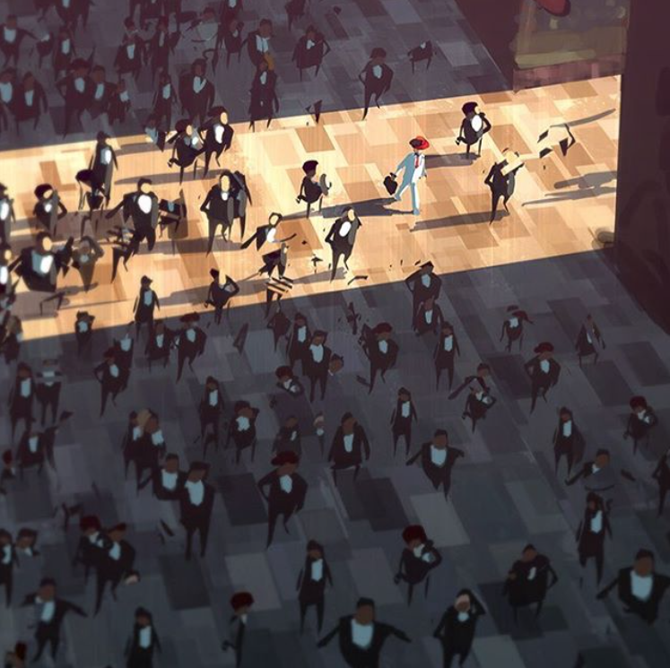

- Where is this?
- Where is the light coming from?
- Who are all of the people?
- Why is the man in the red hat dressed differently to everyone else?
- How do you think the others feel towards him? How does he feel towards the others?
- Do you think he feels proud to be different? Or could he feel ashamed?
- Have you ever done something that made you stand out? How did it feel?
- Do you think people should try to fit in? When is it good to be different? When is it bad?
- Research historical figures who are known for being different, or for standing up for change.
- Compare this image with ‘Different‘. What’s similar and what’s different?

