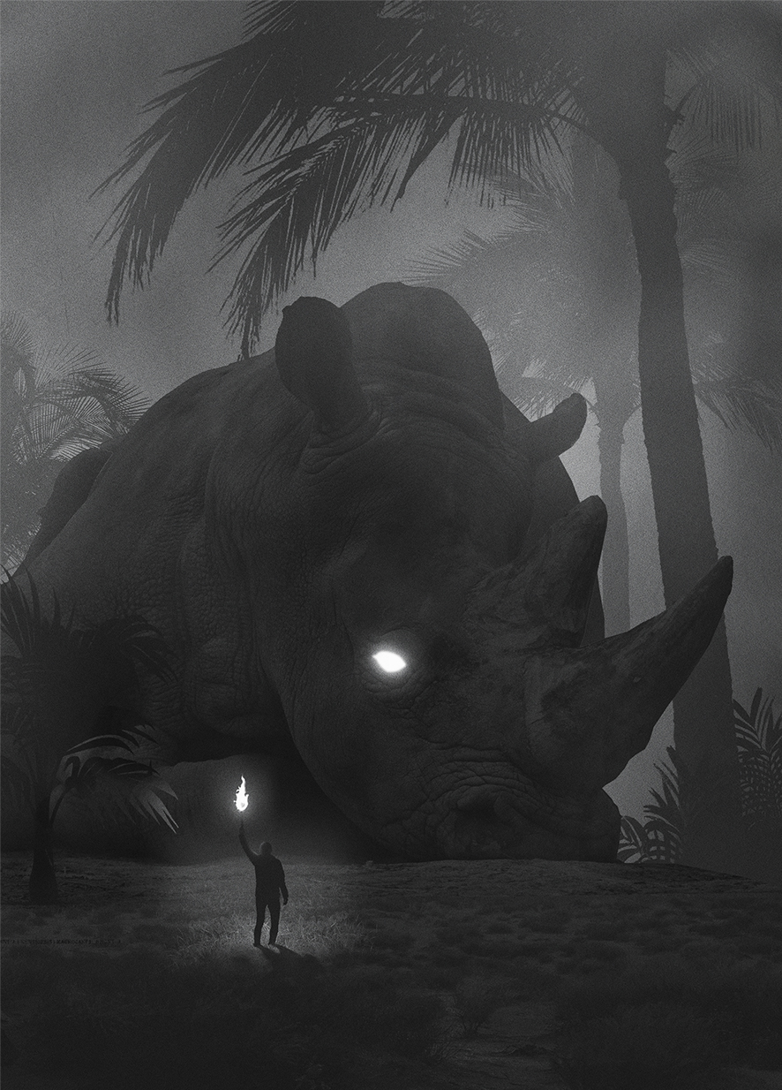

- Why is the picture called ‘Fear’? Is the man fearful? Is the rhino?
- What is fear? List your thoughts, beginning each sentence ‘Fear is…’. Put them together into a poem (like this one: Fear Is). Consider what fear looks like, feels like, and what causes fear.
- Dawid Planeta captioned the picture with this quote:
“One challenge at a time, I try to turn into the face of fear and tell it “you are not my master, you are the product of my self and I am your master.” I look into the monster’s eyes until it disappears. Then I am free.”
― Rohvannyn Shaw
- What does it mean? How does the quote link to the picture?

