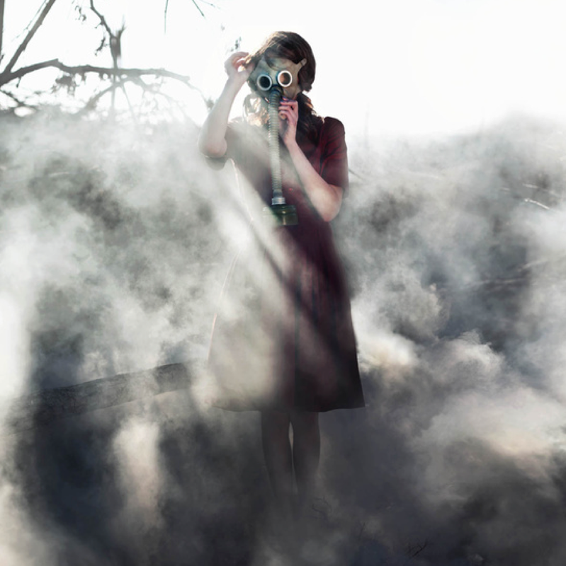

The Trench

The Trench

Question time!
What is war? What causes war? What is the relationship between war and nature? Can war ever be justifiable? Will there ever be world peace?
How do you think Marie is feeling? What will she see as she looks around?

Perfect picture!
Imagine you are wearing the gas mask, standing in the trench. Can you draw what you see in front of you?

Story starter!
Marie stepped out into the barren wasteland that was once her front garden. She remembered before this terrible war had started when she used to play out here with her older sister, swinging from the rope-swing they had hung from her favourite tree. They would dance and play for hours in their beautiful garden; a safe place where Marie felt blissfully happy.
Things had changed. The war had brought great sorrow and pain. She was alone.
Marie stood there in the trench that had once been her safe place. It didn’t feel safe any longer. Once filled with birdsong and the sweet scent of her mama’s roses, it was now a smouldering hell: a painful assault on her senses.
Peering through the swirling fog of death she could make out the hazy shapes of broken things. Everything in the world seemed broken. Her favourite tree that she used to climb was now a blackened stump: a monument in remembrance of the death of nature. Her eyes were appalled at the chaos and destruction that lay all around her. She could feel the fog beginning to sting her skin, the distant pounding of the guns serenading her in this moment of utter despair and sadness.
She gazed around once again…

Sentence challenge!
Can you extend a sentence by adding a subordinate clause?
Can you separate the clauses using a comma?
Can you use one of the following conjunctions to link your clauses: but, or, yet, so?
e.g. Marie had once been blissfully happy in this place, but now there was nothing here but painful memories.
The sun was shining,
The trench was empty,
Marie felt cold,

Sick sentences!
These sentences are sick and need your help to get better!
It was smokey. Marie stood in the trench. She held the mask to her face.

