STANLEY AND CLIVE

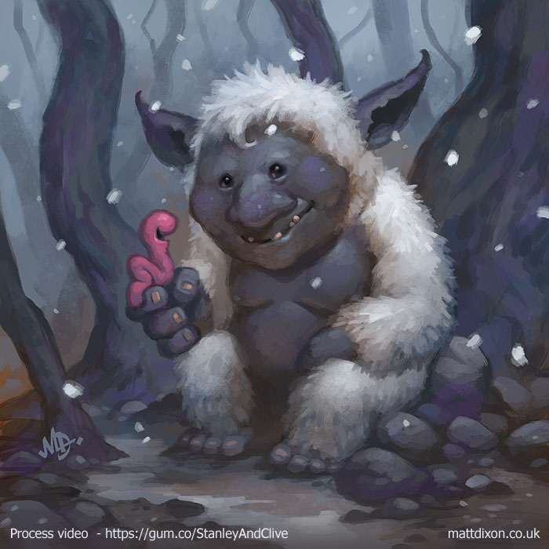

Credit: Matt Dixon

- Which one is Stanley and which one is Clive?
- What kind of creatures are they?
- Have they just met or did they already know each other?
- How do they feel about each other? How do you know?
- How do you feel about them?
- What are they saying? Add speech bubbles to the picture, then write this scene with dialogue.
- What do Stanley and Clive have in common? What are their differences? Is this a bad thing?
- What makes you different?
- Would the world be a better place if everyone was the same? Why/why not?
- Why are Stanley and Clive friends?
- What is friendship?
- What makes a good friend?

