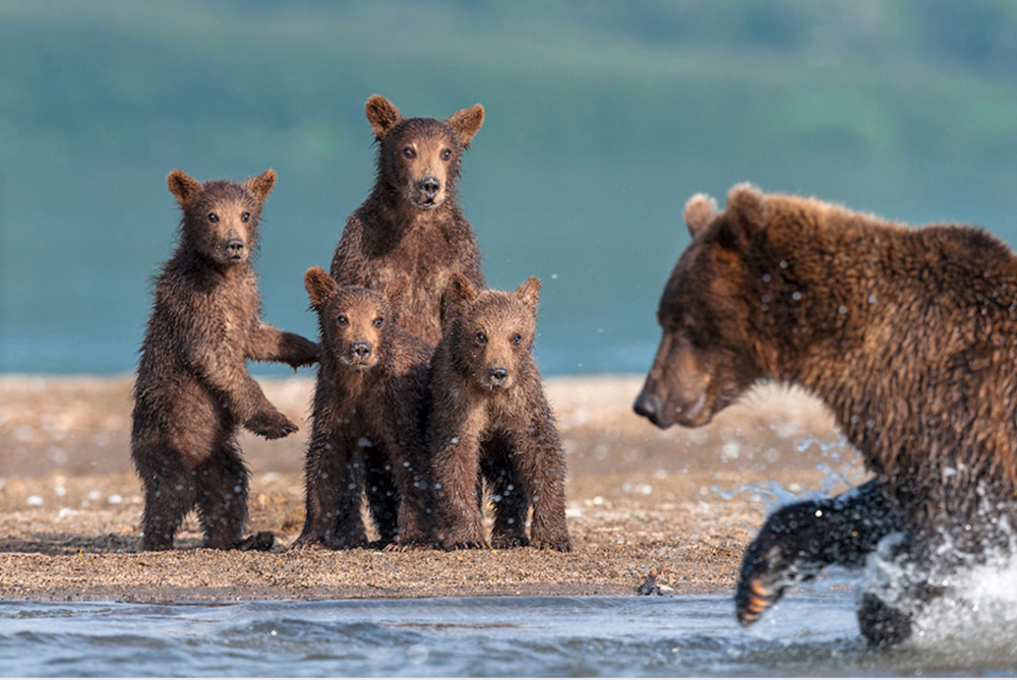

Watch and Learn

Question time!
What do you think the bear cubs are thinking?
Which of them do you think will make the best hunter?
Why do you think the relationship between the mother and her cubs is so important?
Would you rather be a fish or a bear?

Perfect picture!
Imagine you are the fish that the bear is after. Draw or describe what you can see.

Story starter!
Keeping her eyes fixed on the fish, she prepared to pounce.
The ice-cold water made her paws tingle, the sound of the cascading water around her filled her ears, and she could feel her heart pounding inside her chest. Her senses were more alert than ever.
Over years of practise, however, she had perfected the art of blocking out all possible distractions, focusing only on catching her prey.
Her cubs watched from the beach, learning from her every move. She couldn’t afford to teach them bad habits. Every move and every second counted…

Sentence challenge!
Insert three commas in the correct places in the sentence below.
Reluctantly the small brown cub placed his paw into the icy blue water.

Sick sentences!
These sentences are ‘sick’ and need help to get better. Can you help?
The big bear went into the river. Her cubs watched from the beach.

