WHISPERS

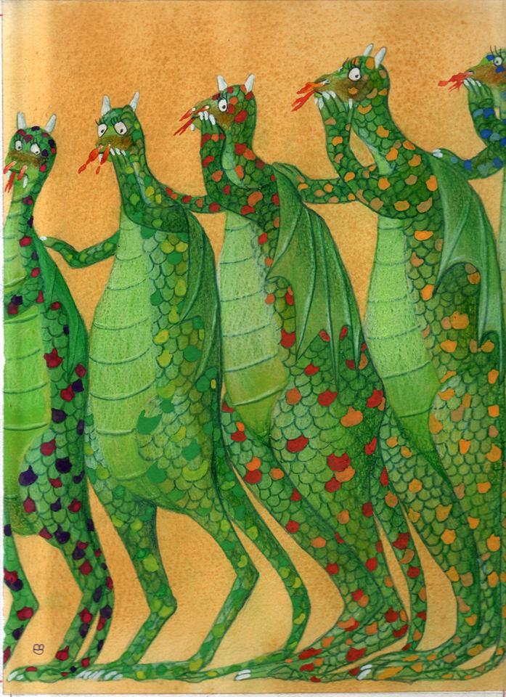

Credit: Nikolas Andrikopoulos

- What are the dragons saying to each other?
- Are they all saying the same thing?
- Why are they holding their hands up to their mouths?
- What are they looking at?
- Do you think they look guilty, or scared?
- Does this image remind you of anything?

