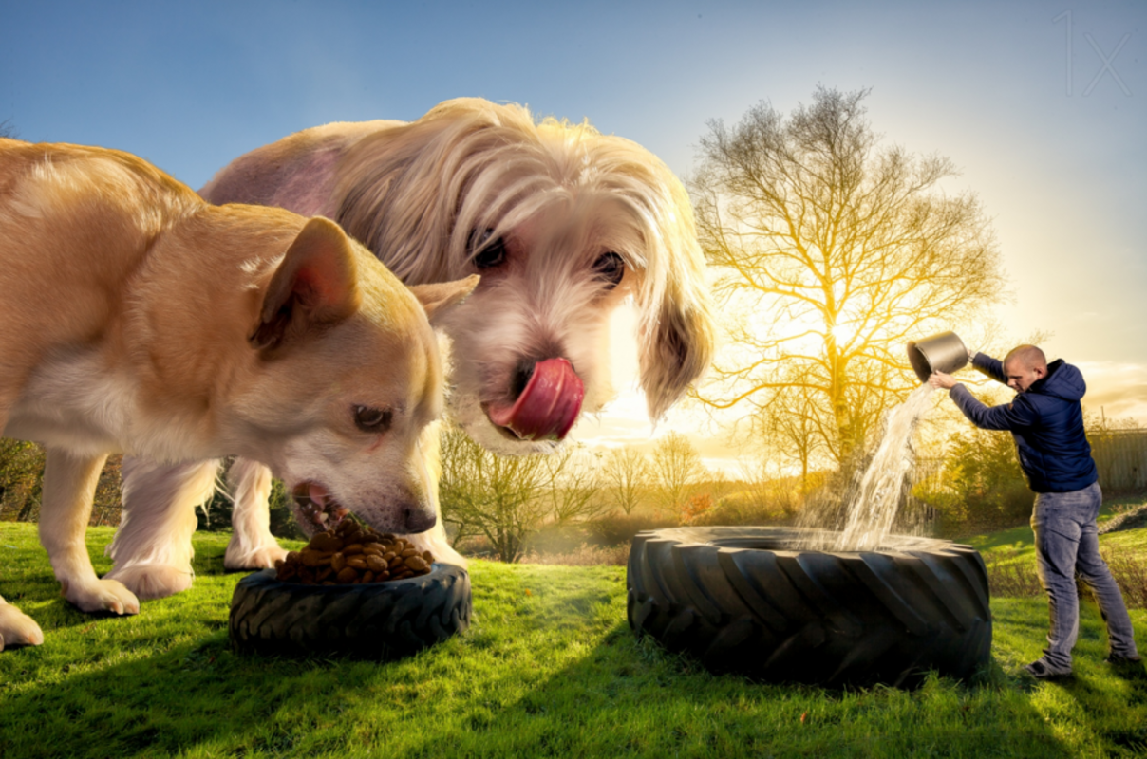

Magic Biscuits

Question time!
What had happened when Brian fed the biscuits to his dogs?
How quickly did they grow to this size do you think?
Did Brian give the biscuits to anything/anyone else?
Have the creatures stopped growing?
How will Brian keep them as pets?
What are the benefits/problems with having such enormous pets?
Is there a way for Brian to restore his animals to their original size?

Perfect picture!
Imagine Brian gave the biscuits to a different animal. Can you draw what they would look like before and after?
Story starter!
Brian had often bought things from the market that had turned out to be the most outrageous, disappointing fakes.
He had presumed that the magic biscuits would have been exactly the same. How wrong he had been...

Sentence challenge!
Can you write use a colon to start a list? Remember to use commas to separate the items in your list!
E.g. To feed his dogs every morning Brian needed: two enormous tractor tyres, a mountain of dog food, a gallon of water and a safe distance between himself and his overgrown chums.

Sick sentences!
These sentences are ‘sick’ and need your help to get better. Can you help?
The dogs ate the biscuits. They started to grow really fast. Now they are big. They need to eat a lot of food.

