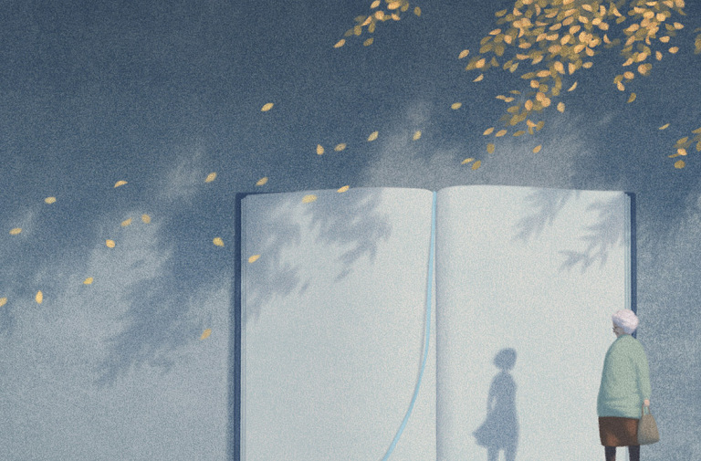
FALL
- Who is the old lady?
- What is she doing?
- What is the shadow? Why isn’t it the same silhouette as her?
- How does she feel as she’s looking at this shadow? What might she be remembering?
- Why is it in a book?
- Why did Jungho Le call this picture ‘Fall’?
- Write the story of this woman’s life. Include flashbacks.
  - What world events has she lived through?
  - What changes has she seen?
  - What was her childhood like?
  - Is she alone now? Has she always been alone? Was she ever married? Did she have children?
  - What are her favourite memories?
  - What’s her personality like? How will you show this through the writing?
  - How might you structure your story?
- Link to the next image (Nostalgia) – compare and contrast.

