5.1.21 T TA I C G
WALT | make inferences about books |  | Stories from other cultures  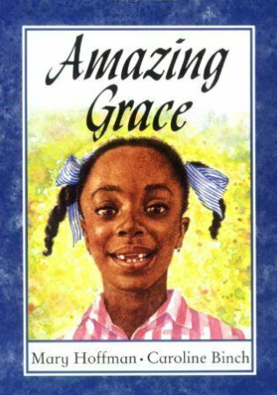
I can… |  | Teacher
 | discuss what I see with my family
 | predict what a book might be about

Take a look at this front cover. Today we will use what we see on the front cover to predict what we think the book will be about. Write down (either on the computer or on paper) Year 1 and 2 complete the first table. EYFS complete the second table.

Questions for Year 1 and Year 2
Look closely and write what you see on the front cover.

Who is this girl?

How old could she be? (Have you noticed the gaps in her teeth? (Think about how old children are when their teeth begin to fall out)

What might her name be and how do you know?

What does the word ‘Amazing’ mean? Write what you think then look in a dictionary (there are lots of online dictionaries, search in Google with your grown-up) and write the definition next to your idea.

Why might Grace be ‘Amazing’? Write a couple of sentences describing what you think she might do that is amazing in the story.

Finally, what do you think this book will be about?

EYFS Questions
Talk with you grown up about all of the things that you see on the front cover?

Who do you think this girl is and how old could she be?

Why do you think the book is called ‘Amazing Grace’?
Write a sentence or two (sounding out all the letters you hear in each word) saying what you think will happen in the story.

