EYFS English
Watch the first part of the ‘Grace and Family’ story (up until 2 minutes and 10 seconds)
https://www.youtube.com/watch?v=lS7UYgN_RGo
11.1.21 T TA I C G
WALT | Talk about how a character feels and why.  Predict what a character might do in the story. |  | Stories from other cultures  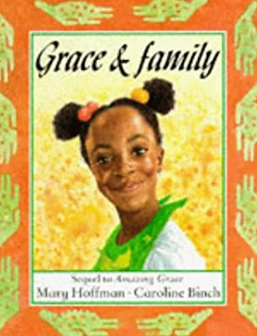
I can… |  | Teacher
 | talk about what has happened in the story so far
 | make links between what has happened and how the character might be feeling
 | Draw a picture to show what Grace wants to do when she visits her dad in Africa

Grown-ups, please write the date and the WALT into your child’s Yellow English book if you are not able to print.
Talk to your grown up about these questions:
- How does Grace feel about the exciting news of her trip to Africa?
- Is she excited to see her dad?
- What do you think she might want to do with her dad when she sees him? (Think about the sorts of things that you do with your family, this might help you with some ideas.)
- Draw a picture and write a sentence or two about what you think Grace will do with her dad when she visits him.

