EYFS English
12.1.21 T TA I C G
WALT | use drawings to track the thoughts of the characters in the story |  | Stories from other cultures  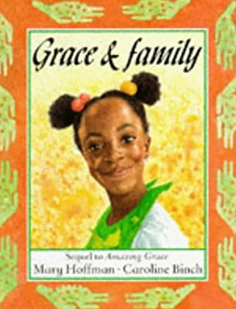
I can… |  | Teacher
 | talk about the different characters and have a go at play acting a part of the story. Create a freeze frame
 | draw a freeze frame of the characters.
 | talk about the actions of the characters in my freeze frame picture using the story to help me with my ideas

Listen to the rest of the story from yesterday:
https://www.youtube.com/watch?v=lS7UYgN_RGo

Grown-ups, please write the date and the WALT into your child’s Yellow English book if you are not able to print.

Today is a little different because we cannot act this out together like we would in our class.
Activity:
Talk to your grown up about all the different things Grace did with her family. Draw a picture of Grace and her family in the story. Write a sentence to say who is in the picture and what they are doing. You can use the grid below or draw and write straight into your books.
Grace with her family

