EYFS English
13.1.21 T TA I C G
WALT | sequence the story using the features of beginning, middle and end |  | Stories from other cultures  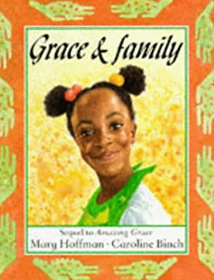
I can… |  | Teacher
 | (EYFS/Y1) I can identify what happens in the beginning, middle and ending of the story.
 | (EYFS/Y1) I can use the story structure to put parts of the story in order.
 | (Y2) I can use the story structure to draw a storyboard of events.

Grown-ups, please write the date and the WALT into your child’s Yellow English book if you are not able to print.
Watch and listen to Grace and Family again if you would like to.
Today we will think about what happens in the beginning, the middle and the end of the story.
Put these pictures in order.
(If you cannot print, draw them in order in your book by copying the pictures.)
Tell a grown up what was happening in the picture in the story and ask them to write the sentence underneath your cut out pictures (or your drawn ones if you couldn’t print). Have a go at writing 1 sentence for yourself. Sound out each word and use finger spaces. Don’t copy this sentence but try yourself with your grown-up near by to help sounding out.

