EYFS English

14.1.21 and 15.1.21 T TA I C G
WALT | write a post card in character  draw the front of the postcard |  | Stories from other cultures  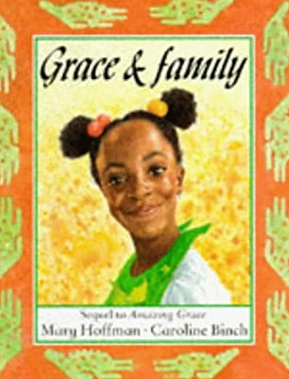
I can… |  | Teacher
 | identify exciting things my receiver will want to know about from my trip
 | write a postcard from the point of view of Grace from the story
 | Look at different postcards with my grown-up and draw the front of my postcard.

Grown-ups, please write the date and the WALT into your child’s Yellow English book if you are not able to print.

What is a postcard? Have you ever been sent one? Take a look at any post cards you have at home and then take a look at the ones below:

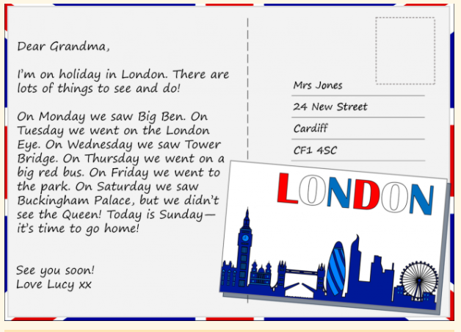

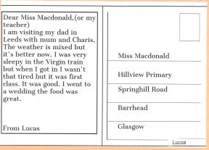
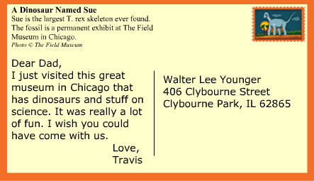

We send postcards when we go on holiday. We can send them to anyone at home who didn’t come with us. Who would you send a postcard to on holiday? Maybe your granny or an older brother or sister?
I want us to imagine that Grace in our story sent a postcard home when she was in Africa. Who would you like her to send a postcard to? It could be a friend at school, her teacher or her mum. You can make the person up if you like.
Use the frame to help you or ask your grown up to draw it in your book. Your grown up can make up an address to go on the postcard. (We write the address of the person we want to receive the postcard.)

Start it by writing: Dear ______. Include what you have done so far with your dad and what has been fun. End it by saying: from _____.
(See page below for frame or open the postcard template from the blog area)

Friday 15th
Postcards have pictures on one side and the writing about the holiday on the other side. Today, ask a grown-up to help you look at some postcards online. (Google image search) What do you notice about them? Can you see pictures of different places from around the world? Talk about what you would like to draw on the front of your postcard. Ask a grown up to help you with ideas and then draw your front in your book. If you printed out the post card yesterday, you could draw the front on this. Keep it safe by sliding into your book. I definitely want to look at these and keep them.

