11.1.21 T TA I C G
WALT | write a diary from the point of view of the main character |  | Stories from other cultures  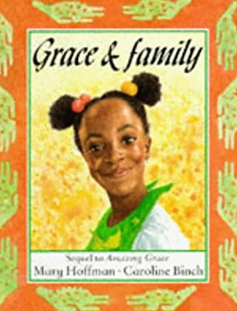
I can… |  | Teacher
 | talk about what has happened in the story so far
 | make links between what has happened and how the character might be feeling
use features of diary writing
(first person ‘I’ and ‘Me’, chatty language, chronological)

12.1.21 T TA I C G
WALT | use drawings and drama to track the thoughts of the characters in the story |  | Stories from other cultures
I can… |  | Teacher
 | talk about the different characters and have a go at play acting a part of the story. Create a freeze frame
 | draw a freeze frame of the characters.
 | talk about the actions of the characters in my freeze frame picture using the story to help me with my ideas
 | Write down a couple of sentences to describe what is going on in my freeze frame.

13.1.21 T TA I C G
WALT | sequence the story using the features of beginning, middle and end |  | Stories from other cultures
I can… |  | Teacher
 | (EYFS/Y1) I can identify what happens in the beginning, middle and ending of the story.
 | (EYFS/Y1) I can use the story structure to put parts of the story in order.
 | (Y2) I can use the story structure to draw a storyboard of events.

14.1.21 T TA I C G
WALT | write a post card in character |  | Stories from other cultures
I can… |  | Teacher
 | identify exciting things my receiver will want to know about from my trip
 | write a postcard from the point of view of Grace from the story
 | choose the style of my writing based upon who I am writing to (formal for teacher, informal for mum or friends)

15.1.21 then 18 and 19.1.21 T TA I C G
WALT | plan my story using a story map planner  (3 sessions) |  | Stories from other cultures
I can… |  | Teacher
 | draw a story map that includes a beginning, middle and ending
 | innovate my story by changing details such as characters or story events
 | use my story map to tell my story to a family member or friend

